A+ 100 Gardens Plant List

Transplants: -- Peppers

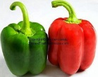 California Wonder Large Bell Heirloom 12” Spread
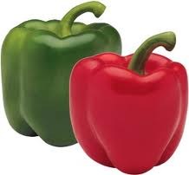 Lady Bell Sweet Bell 12” Spread
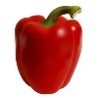 Red Knight Blocky Early Maturity 18” Spread
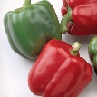 Baron Sweet Bell 18” Spread
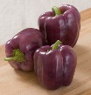 Islander 3 Lobed Lavender Bell 18” Spread

Transplants: -- Tomatoes
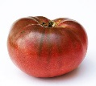 Cherokee Heirloom Purple 18” Spread
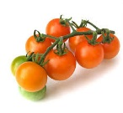 Sun Gold Cherry Sweet 18” Spread
Big Beef Large Classic 18” Spread
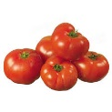 Brandywine Mild Heirloom 18” Spread

Seeds
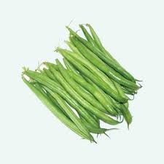 Provider Bush Beans 1” Deep 6” Spacing

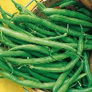 Derby Thin String bean 18” Spacing

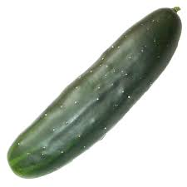 Marketmore Slicing Cucumber ½ Deep 18” Spacing

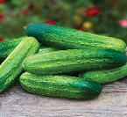 Pick a Bushel Cucumber Bush Pickle 20” Spacing

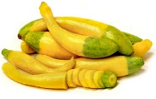 Zephyr Summer Squash ½ Deep 18” Spacing

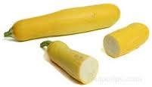 Golden Golden 6-8” Zucchini 48” Spacing

