Abstract
GROWTH RESPONSE OF CHRYSANTHEMUM (MORIFOLIUM) TO BIOCHAR AMENDMENTS IN CONTAINER SUBSTRATE.
L. Ennis, K. Pusey -Parkside High CTE, Wicomico Maryland FFA

There have been numerous studies related to the positive impacts of using biochar in organic crop production. These studies have shown that the biochar boosts water holding capacity and reduces amounts of fertilizer needed. However, there has been both few studies or adoption in the greenhouse container production setting that tests biochar efficiency related to container ornamental or vegetable plant production.

The study conducted, used two regimens of biochar as a container substrate amendment to the normal peat/bark-based pot formulation used during summer production of Chrysanthemums. Chrysanthemum production requires relatively large amounts of fertilizer to both establish plants and maintain fertility. The study hypothesized that the addition of the biochar would add both efficiency to the mineral uptake and moisture availability with improved plant vigor and less disease pressure during production. Measurements conducted were branching, height and biomass of plants from establishment to finishing stages of growth. (8 weeks) Uniform rates of irrigation and fertilization were maintained for all three tested groups.

The application of the Biochar had a significant positive contribution to branching, height and biomass compared to control. There were no signs of root/ foliar/insect stress during study period. The use of biochar in the greenhouse production setting as part of a fertility management plan should be fully considered. This field trial indicated the potential for this formulation to both stimulate plant growth and reduce costs.

Introduction
A typical container nursery may grow 50-250 species of plants at any one time, with numerous cultivars of each species, depending upon market demand and the ability of employees to care for a diverse range of plant requirements. Container produced plants are more susceptible to stresses than field grown plants due to the limited root space, soilless substrate and dependency on irrigation. Finding a perfect balance between the media in the pot that will hold both water and minerals supplied (less leaching) and at the same time provide porosity (air space) with the demands of specific crops is challenging. The typical methods of providing nutrients in greenhouse crop production are continuous liquid nutrient feed or a slow release dry fertilizer. A common problem in both these methods is the loss of minerals through leaching or the buildup of salts in the pot that burn newly developing roots.

This study using biochar as a substrate amendment alongside the typical nutrient program of chrysanthemums hopes to replicate positive results found in organic garden setting. It is hypothesized that the biochar will add efficiency to the nutrient program by providing increased holding capacity of nutrients and moisture. Biochar should provide improved plant nutrient availability and reduce the amounts of fertilizer needed and minimize the amounts of nutrient runoff saving both time and money for greenhouse growers.

Literature review

Compost is popular in organic agriculture because it replaces synthetic fertilizers and improves soil fertility. New compost derived products such as biochar are less common yet have shown increasing interest.( Study) Biochars are obtained by burning organic matter in the absence of oxygen. Most of the soilless mixes used by container growers are a mixture of bark, peat, perlite and vermiculite. The problem with adding composted material in these formulations is getting a consistent blend or weight across the product offering. Therefore, most container mixes start with a starter charge of synthetic fertilizer to provide the initial nutrients needed for container plants. With the introduction of biochar growers can add biology or fertilization in a uniform and consistent program of delivery and expect less runoff and improved availability to plant.” The pores in biochar provide a suitable habitat for many microorganisms by protecting them from predation and drying while providing many of their diverse carbon (C), energy and mineral nutrient needs. With the interest in using biochar for promoting soil fertility, many scientific studies are being conducted to better understand how this affects the physical and chemical properties of soil and its suitability as a microbial habitat.” (2018) Cropping methods using biochar have found significant positive yields. A rice and vegetable production study found plant weights to increase by approximately twenty to thirty percent.
Materials and Methods

We used thirty chrysanthemums (Chelsey White plugs) and planted them in 10” mum pans on raised benches in greenhouse with shade covering for two weeks then moved outside to benches with drip line irrigation. We randomized the setting of 10 mums as the control (no biochar), 10 mums (red-5% biochar ) and 10 mums (blue- 10% biochar).

Cool Terra Biochar is the product we used.
________________________________________________________________________

__________________________________________________________________________

Fertilizer: Plantex 20-10-20

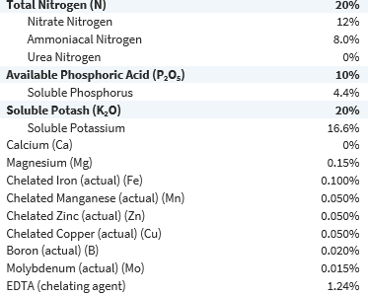

Fertilizer Plantex 15-0-15

Study began in Week 26 (June 25) and completed Week 34 (August 21). We used weekly 20-10-20 and 15-0-15 fertilization schedule to maintain EC at (1.5 first two weeks and 2.0 next 6 weeks) Pour Through Method and PH of 6.0.

To measure as hypothesized the response of plant in height, branching and biomass, each plant (green/red/blue) was recorded biweekly in height/#of branches and took average for that group. In week 30 and 34 we measured the biomass weight of two specimens from each plant group. We took the largest and smallest specimens from that group measured by height and averaged their biomass for the study biomass calculation.

Results
As hypothesized the application of the biochar had significant contribution to height, branching and biomass compared to the control that had no application. (See Figure 1,2,3) We found in the first four weeks of production (establishment) that the control outperformed the treatment groups. In the following weeks (growth stage) the treatment groups outperformed the control significantly. The representative gains between the two treatment groups was significant as it related to biomass and root development. We found no differences in bud initiation timing between groups. There were no signs of root or foliar disease among any of the mum groups.

Throughout the eight-week study between the control and biochar the 10% (Blue) samples showed an increase of 75% in height, 35% branching and 51% in biomass. Between the control and the 5% (Red) samples showed an increase of 25% in height, 25% branching and 31% in biomass was found. In the two treatment groups there was a incidence of PH drift upward during study compared to control
Figure 1 (Green Control No treatment, (Red )5% Biochar, (Blue) 10% Biochar
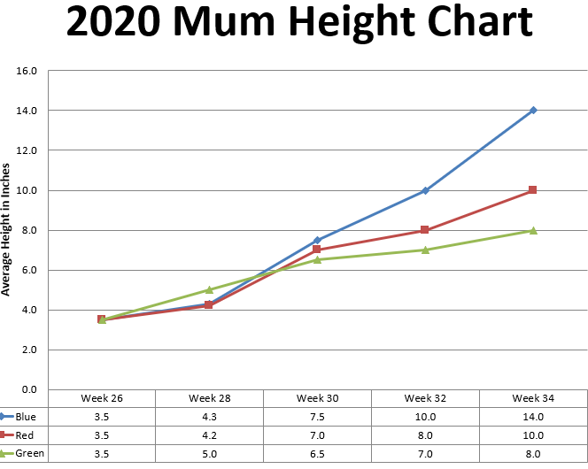

Figure 2.
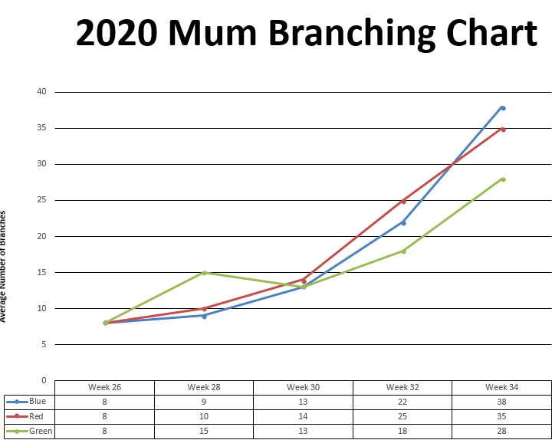

Figure 3.
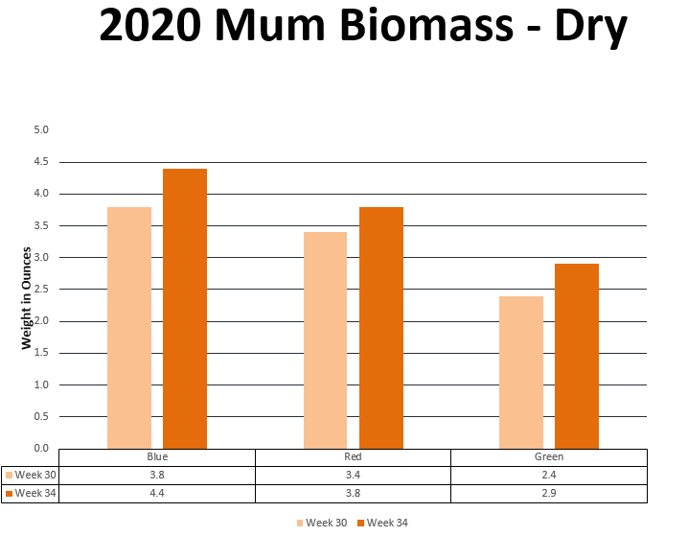

Discussion and Conclusions.

Greenhouse production growers want to grow beautiful plants that will not only sell but do well in the landscape once planted. Growers are looking for (1) improved plant root development and plant growth (2) Increased quality and quantity of flowers/fruits (3) Improved nutrient and water intake (4) Increased resistance to stress, root disease and transplant shock. This initial study showed that the use of Biochar as an amendment to the container substrate can have positive benefits for plants like those found in studies from organic field growing environments.

The significant increases of 75% in height, 35% branching and 51% in biomass point to the efficiency in root development, nutrient efficiency and water uptake. In the second week height measurement (week 28) there was a surprising difference as the control was 7/12inch higher than the two-treatment sample. This was reversed by (week 34) at the end of the study with the 10% biochar two-treatment 6” higher.

As this study maintained two biochar proportions, further study would be appropriate to measure the response of each biochar group with varying application rates of fertilizer. The industrial fertilizers were applied on the same weekly constant feed bases for all groups in a 20-10-20 or 15-0-15 Nitrogen/Phosphorous/Potassium ratio. When measured across the eight weeks study the fertility levels remained surprisingly close (measured in EC) compared to the significant difference in plant growth between groups. This suggest that the minerals applied bound to the biochar mix in the pot rather than being washed out of pot during irrigation. In the two treatment groups there was a very slight incidence of PH drift upward that required adjustment using relative larger than expected amounts of 20-10-20 nitrate-based fertilizer to adjust PH downward.

During the study there were no problems related to stress/ disease or insect pressure in any of the groups. A comparative study across many seasons with varying climate scenarios then the 2019 summer would have to be studied. With the significant increase in root formation in the supplemented treatment groups it would be interesting to compare the relative drought tolerance in further studies. As only one crop was studied (Chrysanthemums) it will be necessary to evaluate the response of other greenhouse crops to these applications. Further studies should consider comparative reductions in industrial fertilizers while holding constant biochar applications. This study showed initial possibilities for ornamental or vegetable greenhouse container plant production using biochar. Additional trials with other crops should be evaluated.

References
Study highlights biochar's potential in horticulture. Retrieved from https://www.soils.org/discover-soils/story/study-highlights-biochars-potential-horticulture

(2018). FAQs - biochar-international. Retrieved from https://biochar-international.org/faqs/

NC, V. (2014, January). Biochar Treatment and its Effects on Rice and Vegetable Yields in Mountainous Areas of Northern Vietnam. Retrieved from https://pdfs.semanticscholar.org/2e92/9cbddaf662e9a3b694956ce21be2624632d0.pdf
Acknowledgements
We would like to thank our FFA Advisor Mr. Jerry Kelley for his direction, suggestions and support with this study.

