CAREER TECHNICAL EDUCATION PARTNERSHIPS
FACILITATIONS AND BARRIERS

Jerry Kelley
CTED 650 Research in Career and Technology Education II
Dr. Thomas Loveland
May 2, 2021

Acknowledgements:

The writer wishes to thank the following people for their support, assistance and inspiration in the development of this research project.
Dr. Thomas Loveland
Bryan Ashby
Wicomico County District CTE
Partners and Students of Parkside CTE Horticulture
Patricia Kelley
Christine Forst
Nancy Viola
Violet Kelley

Abstract:
The purpose of this study will be to evaluate the relative strength in partnership
development in local Career Technology Education (CTE) programs. CTE programs share a
common challenge in their efforts to develop and strengthen their partnerships. Partnerships are
not easy to cultivate and sustain. As CTE programs align new and existing programs with college
and career ready standards, CTE programs of study engagement with schools, communities,
industry, and post-secondary institutions will be increasingly necessary. Research regarding CTE
partnership facilitations and limiting barriers can provide individual teachers and administrators
specific targets for attention. With the potential availability of CTE partnership resources and the
willingness and capability of CTE programs to utilize them, this study will explore the current
profiles of partnership development within an CTE district. Specifically, this study will seek to
discover the current needs or strategies used that sustains the network of CTE partnerships in the
district participating in this study. CTE partnership research findings would be a valuable starting
point for professional development and new teacher orientations. A survey was developed and
distributed to 38 CTE program of study instructors. The study measures alignment to partnership
criteria and relates teacher perceptions regarding factors associated with that criteria.

Table of Contents:

Abstract:…………………………………………………………………………………….. 2
Table of Contents………………………………………………………………………… 3
List of Tables……………………………………………………………………………….. 6
Table of Figures………………………………………………………………………………….7
Chapter 1.
Introduction…………………………………………………………………………………........8
Purpose and Significance of Research……………………………………………………….....10
Statement of Problem …………………………………………………………………………..11
Research Questions……………………………………………………………………………..12
Definition of Terms……………………………………………………………………………..12
Research Limitations………………............................................................................................13
Research Methodology.................................................................................................................13
Summary…………………………............................................................................................ 14

Chapter 2.
Introduction……………………………………………………………………………………..16
Perkins Partnership Alignment....................................................................................................16
National Partnership Frameworks………………………………………………………………17
Partnership Recruitment, Structure, Activities………………………………………………….22
Partnership Facilitations and Outcomes………………………………………………………...23
Partnership Barriers……………………………………………………………………………..25
Summary………………………………………………………………………………………..25

Chapter 3.
Methodology Introduction……………………………………………………………………...27
Research Questions……………………………………………………………………..............27
Research Design………………………………………………………………………………...28
Population and Sample………………………………………………………………………….28
Study Variables……………........................................................................................................29
Instrumentation…………............................................................................................................30
Data Collection……………………………………………………………………………….…34
Analysis of Data………………………………………………………………………….……..35
Summary……………..................................................................................................................36

Chapter 4.
Introduction………………..........................................................................................................37
Research Question #1: To what degree are the elements used as criteria for the ACTE High Quality CTE Program of Study Framework/Partnerships (ACTE HQP) evident in local CTE programs?.....................................................................................................................................38
Research Question #2: Regarding partnership structures and recruiting efforts. What are your supports or how are individuals involved? What is needed?.......................................................39
Research Question #3: Regarding partnership activities. What are your supports or how are individuals involved? What is needed? ………………………………………………………...40
Research Question #4: Regarding student exposure and interactions with partners. What are your supports and how are individuals involved? What is needed? Please explain……………41
Research Question #5: Does the number of years a CTE teacher has worked in the career field prior to teaching have an impact on their partnership profile?....................................................42
Research Question #6: Does the number of years teaching CTE have an impact on program partnership profiles?....................................................................................................................43
Research Question #7: Does the general industry type of CTE program of study have an impact on program partnership profiles?.................................................................................................44
Summary…………………………………………………………………………………….….45

Chapter 5.
Introduction……………………………………………………………………………………..47
Conclusions……………………………………………………………………………………..47
Implications for Education……………………………………………………………………...51
Recommendations……………………………………………………………………………....52
Further Study……………………………………………………………………………………53
Conclusion……………………………………………………………………………………....54
References……………………………………………………………………………………....55

List of Tables:
Table 1 - Programs of Study: Local Implementation Readiness and Capacity for Self- Assessment……………………………………………………………………………....19 Table 2- Partnerships Self-Assessment Ranking of Status and Importance……………22
Table 3- Study Variables………………………………………………………………..30
Table 4- Research Question Data Source………………………………………………..34
Table 5- Teacher Program of Study Frequency and Percent…………………………….38
Table 6- Teacher Years in Career Field Frequency and Percent…………………...……38
Table 7- Teacher Years Teaching CTE Frequency and Percent…………………………38
Table 8- Population Partnership Mean Totals……………………………………...……39
Table 9- Partnership Structures and Recruiting Efforts Group Means/Themes………....40
Table 10- Partnership Activities Group Means/Themes…………………………………41
Table 11- Partnership Student In Interaction Means/Themes……………………………42
Table 12. Teacher Years in Career Field Group Criteria Values………………………...43
Table 13- Teacher Number of Years Teaching CTE Group Criteria Values …………...44
Table 14- CTE Program of Study Group Criteria Values……………………………….45
Table 15- Teacher Theme Response Totals……………………………………………..46

Table of Figures:
Figure 1- ACTE Business and Community Partnership Elements……………………………......9
Figure 2- ACTE Business and Community Partnership Elements…………………....................22
Figure 3- Mean Distribution Partnership Criteria Totals…………………………………….......39
Figure 4. Years in Career Field Group Criteria Average………………………………………...43
Figure 5- Years Teaching CTE Group Criteria Average………………………………………...44
Figure 6- Program of Study CTE Group Criteria Average…………………………………........45

Chapter 1.
Introduction
In July of 2018, President Donald Trump signed the Strengthening Career and Technical
Education for the 21st Century Act. “The purpose of this federal funding was to develop the
academic knowledge, technical and employability skills more fully of secondary education and
postsecondary education students who elect to enroll in career and technical programs.”
(CTE.ed.gov, Perkins V. p. 1.)
Key provisions of Perkins V included:
- Increase employment opportunities for subgroups and special populations.
- Include preparation in high-skill, high-wage, or in-demand occupations.
- Integrate challenging academic and CTE instruction, linking to post-secondary education.
- Provide technical assistance that improves quality of CTE faculty, teachers, counselors, and administrators.
- Support partnerships between secondary, postsecondary, local workforce boards, business, and industry
Accordingly, “Perkins V has continued a push toward more systemic partnership,
particularly with business and industry, incorporating labor market alignment into the definition
of programs of study and requiring extensive stakeholder engagement on the local level.”
(ACTE online,2019, p.2) Fundamentally, Perkins V requires improvement in student readiness
and employability by funding support for high quality student preparation that is aligned,
integrated and in partnership with, high quality destinations of opportunity for students.
In 2018, the Association for Career and Technical Education (ACTE) published a
framework designed to answer the question “What is high-quality CTE?” The research-based
framework was designed to apply to individual or a local CTE programs of study. Of the
framework’s twelve elements and ninety-two criteria, business and community partnerships were
considered a key element. This key element addresses partnership recruitment, partnership
structure, and the wide variety of activities partners should be engaged in to support the program
of study and align with workforce needs. The (ACTE, 2018, p.4) defining quality business and
community framework element and the associated criteria are below.
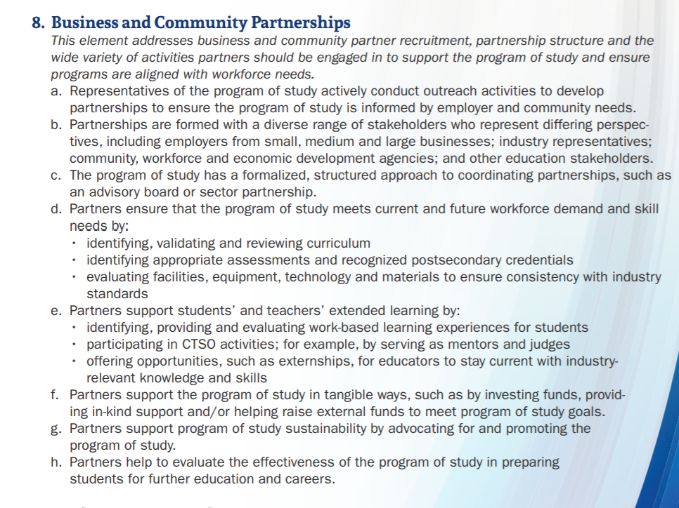
Figure 1. ACTE Business and Community Partnership Elements
Criteria “A” and “B” of the framework elements above addresses the importance of CTE
programs conducting outreach to both be informed by employers and the greater community and
to establish a diversity of stakeholders with differing perspectives. Criteria “C” from above,
addresses the importance of having an established and formalized structure of advisory of
industry expertise and local knowledge. The following criteria “D”, “E”, “F”, “G” and “H”
addresses critical program partnership activities that in multiple ways supports program
alignment with current industry standards and student opportunities. In the ACTE CTE total
framework developmental process mentioned above “the topic that appeared most frequently
was the involvement of business partners, followed by the involvement of education partners.”
(“ACTE, 2019, p.2) A 2013 national study of 20,000 CTE educators found, “the biggest gap
between the importance of program components and satisfaction levels was in access to industry
partners and mentors.” (Education Development Center, 2014, p.10)
Purpose and Significance of Research
The purpose of this study will be to evaluate the relative strength in partnership
development in local CTE programs of study. The study will measure alignment to partnership
criteria and relate teacher perceptions regarding barriers and facilitating factors associated to that
criteria.
A diverse range of partners and partnership collaboration is fundamental to CTE program
quality and student opportunities. A CTE high quality partnership profile would be considered to
include a diverse range of stakeholders, who understand their responsibilities, and participate in a
range of activities. CTE programs aligned with meaningful partnerships with community and
industry help provide programs with additional technological resources, insights, and ideas that
shape curriculum, operational infrastructure, and valuable workplace orientations for students.
The research questions for this study address partnership criteria in recruitment, partnership
structures in place and partnership activities. This research survey can be used as the evidence
base for district-wide evaluations regarding partnership patterns and structures. Research
regarding CTE teacher partnership profiles could benefit all CTE stakeholders in the continuing
effort toward improvement.
With the potential availability of CTE partnership resources and the willingness and
capability of CTE programs to utilize them, this study will explore the current profiles of
partnership development within an CTE district. Specifically, this study will seek to discover the
current limiting barriers or facilitating strategies used that sustains the network of CTE
partnerships in the district participating in this study. Research regarding CTE partnership
facilitations and limiting barriers can provide individual teachers and administrators specific
targets for attention. Partnership research findings would be a valuable starting point for
professional development and new teacher orientations.
Statement of the Problem
“Career and technical education is a unique component of the American education
system. Spanning K-12 and postsecondary, CTE is intentionally the most outward facing
curriculum. No other program, if developed well and implemented with fidelity, requires the
same elevated level of advisement and engagement of external stakeholders.” (ExcelinEd.org,
2018, p.7) Career Technical Education (CTE) programs share a common challenge in their
efforts to develop and strengthen their partnerships. Partnerships are not easy to cultivate and
sustain. As CTE programs align new and existing programs with college and career ready
standards, CTE program engagement with schools, communities, industry, and post-secondary
institutions will be increasingly necessary.
Inherent in the development of expanded CTE partnerships are the challenges and
sometimes inability of CTE programs and partners to find common understandings, shared
priorities, and mutual benefits. “The reason for and manner by which stakeholders are identified
and engaged sets the stages for how well the overall CTE effort meets its goals in a timely
fashion and with minimal setbacks.” (ExcelinED.org, 2018, p.7)
A 2018 survey of nearly eight hundred CTE teachers conducted by the Student Research
Foundation reported significant results related to teacher retention alongside frustrations with
external engagements. Of the CTE teachers surveyed, thirty-seven percent plan to leave the
teaching profession within next five years, forty eight percent are frustrated because of the
quality of external collaborations, and sixty percent say improving business/industry engagement
should be a top priority. Advance CTE, a nonprofit representing CTE directors and leaders,
conducted a survey of CTE directors, teachers, and administrators. Key findings included: “98%
percent of State Directors stated that increasing access to industry experts in high schools is a
key priority today. 100% percent stated that it will be an increasingly large priority in the future.”
(Advance CTE, 2016, p. 2)
Industry and community professionals who have competing priorities and limited time to
engage with CTE programs and students exacerbate partnership efforts. Accordingly, schools
have to find ways to connect with industry professionals in a manner that facilitates expertise in
the classroom. How can we both facilitate and reduce barriers to partnership development that
are fundamental to CTE program quality?
Research Questions
The following are research questions studied in this report:
Main Research Question Criteria A-H.
- To what degree are the elements used as criteria for the ACTE High Quality CTE Program of Study Framework/Partnerships (ACTE HQP) evident in local CTE programs?

Other Research Questions:
Recruiting and Structuring Partnerships
- Regarding partnership structures and recruiting efforts. What are your supports or how are individuals involved? What is needed?
Partnership Activities
- Regarding partnership activities. What are your supports or how are individuals involved? What is needed?
Student and Partnership Exposure and Interaction
- Regarding student exposure and interactions with partners. What are your supports and how are individuals involved? What is needed? Please explain.
Variables of Demographic Influence, Criteria CTE Teachers
- Does the number of years a CTE teacher has worked in the career field prior to teaching have an impact on their partnership profile?
- Does the number of years teaching CTE have an impact on program partnership profiles?
- Does the general industry type of CTE program of study have an impact on program partnership profiles?

Definition of Terms
ACTE: Association for Career and Technology Education (ACTE online, 2019)
Career and Technical Education: The alignment of education-to-occupation pathways meeting
the immediate and long-term needs of the state. (ExcelinED.org, 2018, p.3)
Collaboration: Bringing together industry and education stakeholders who have a vested interest in each other’s success allows students to obtain careers upon graduation and employers to hire qualified employees. (King 2020)
CTE: Career Technical Education (Maryland State Department of Education, 2019)
Elements: The twelve organizing divisions of the ninety-two criteria subsets of the ACTE high quality CTE framework.
Frameworks: standards, rubrics, and documents outlining key CTE program characteristics.
Stakeholder: A stakeholder is anybody who can affect or is affected by an organization, strategy, or project. They can be internal or external and they can be at senior or junior levels.
(Stakeholdermap, 2014)

Partnership activities: Partnership involvement to ensure programs are aligned with workforce and community need. (ACTE online, 2019)

Partnership CTE - A stakeholder-integrated approach to cooperative education involving formalized sustainable relationships between stakeholders. (Fleming and Hicky, 2012)
Perkins V: The Strengthening Career and Technical Education for the 21st Century Act was signed into law by President Trump on July 31, 2018. (CTE.ed.gov, Perkins, 2020)
Program of Study: A structured sequence of academic and career and technical courses leading to a postsecondary-level credential. (CTE.ed.gov, Initiatives, 2020)
Research Limitations

Research findings are from one CTE District. Organizational factors can significantly impact partnership profiles.
Eleven instructors surveyed co-teach in same course.
Self-evaluations can be skewed based on timing of survey. School events can affect participation and focus.

Due date for completion is May 2021.

Impact of online teaching due to COVID.

Research Methodology

As previously noted, the purpose of this study will be to evaluate the strength of
partnership development in local CTE programs. With survey data from district CTE teachers, a
understanding of the form and scope of partnership development within that district will be
evaluated. To evaluate the relative strength in partnership development, the study will measure
alignment to partnership criteria and relate teacher stated perceptions regarding barriers and
facilitating factors associated to that criteria.
Survey data will be from thirty-two CTE instructors in Wicomico County Maryland. The
instructors sampled will cover twenty courses of study. The research will use a concurrent mixed
quantitative and qualitative method. The research questions will be both a Likert scale and open-
ended response format. Quantitative survey data will be aligned with the underlying criteria from
the ACTE High Quality Framework Element: Business and Community Partnerships. (ACTE
online, 2018, p.4) Evaluation Criteria will use Likert Scale (1 = Not at all achieved) (2.
Minimally achieved) (3. = Moderately achieved) (4. =Substantially achieved) For each criteria
responses will be accumulated and mean, and standard deviation assigned. Achieved scores for
each criteria will be ranked for discussion purposes.
Convergent qualitative survey questions aligned as follow-up from partnership quality
criteria responses will give each respondent opportunity to expand on their situational
dynamics of partnership facilitations or needs to that criteria. These expanded responses will be
coded using the constant comparative method to develop major and minor themes of partnership
facilitation and occupying barriers.
Variables of demographic influence on partnership profiles including number of years in
career field, years of CTE teaching, and the generalized category of CTE program of study will
be studied. Accumulated respondent demographic categories and the achieved mean score
partnership data will be compared for discussion.
Chapter Summary

The numerous cited reports in this chapter describe the necessity and importance of CTE
programs establishing stakeholder bonds, bridges, and linkages. As stated above, CTE programs
require an elevated level of engagement with external stakeholders. This study will examine the
identity and status of CTE partnerships in their developed extensions and sustained structures.
The study questions are aligned to survey responses from standard based partnership
criterion to provide a generalized profile of CTE teacher engagement in partnership
development. The partnership insights will be situated in three categories: recruitment,
coordinating structure, partnership activities and partner student engagement. Open ended
questions will provide insights into the factors of support and need in CTE partnership
development. In the findings from this study, of particular interest will be the understandings
related to partnership supports, coordinating structures, shared purposes, goals, and means of
achieving those goals. This study can be used by individual CTE teachers and administrators in
evaluating partnership program profiles for developing opportunities and professional
development.

Chapter 2.

Introduction
Career Technical Education (CTE) has long incorporated employer partnerships in the
development of programs and the provision of workplace opportunities for students. In the recent
decade, National, State, and local CTE leadership have made it a goal to develop more
systematic alignment and inclusion of diverse partnerships with business and community. This
goal has been supported through federal policy, including the School-to-Work Opportunities Act
of 1994, and the following Perkins IV and Perkins V legislation. The goal of these federal
policies has been the continued focus on labor market alignment and definitions of programs of
study that lead to high quality preparation and destinations for students. CTE programs are
increasingly subject to state and federal accountability systems that mandate improvement in key
indicators toward student and program success. Aligned to these accountability mandates has
been the development of benchmarks, frameworks, and rubrics that support the identifying
characteristics of high quality CTE. As a means to achieving these goals, federal and state
mandates are increasingly requiring extensive partnership engagement at the local level.
Partnership development remains a key indicator of CTE program of study success.
Perkins: Partnership Alignment
The Strengthening Career and Technical Education for the 21st Century Act. (Perkins V,
2020) added new requirements for local Career Technical Education programs. “One of the most
significant changes in Perkins V is the new requirement for local eligible recipients to conduct a
comprehensive local needs assessment and update it at least every two years.” (ACTE online,
2019, p.1) The implementation of the local needs assessment requires CTE leadership to evaluate
how their programs measure up on federal accountability standards, scope, and size of programs,
quality of programs, progress in implementation of programs of study, recruitment, retention,
and training of teachers and progress in improving access and equity. “Ultimately, the local
needs assessment process is about helping you make a more formal shift from merely collecting
information to using information to ensure your local CTE programs help create success for
students and employers.” (ACTE online, 2019, p.2) Perkins V accents the importance of
partnership development in local CTE programs by requiring consultation with a diverse
range of stakeholders in the needs assessment development. Perkins V outlines at a minimum the
participants who should be engaged in the assessment and development of the local Perkins
funding application. Uniquely, Perkins V specifies who should be engaged in the local needs
process and ongoing consultation.
- CTE program representatives at the secondary and postsecondary levels, including teachers, faculty, administrators, career guidance and advisement professionals
- State or local workforce development board representatives
- Representatives from a range of local businesses and industries
- Parents and students
- Representatives of special populations
- Representatives from agencies serving at-risk, homeless, and out-of-school youth
- Representatives from Indian Tribes or Tribal organizations, where applicable.
(ACTE online, 2019, p.2)
Highlighting the need for partnership development between CTE secondary and postsecondary institutions are key provisions in Perkins V providing for expanded student opportunity.
“In a much more expansive way than Perkins IV, Perkins V encourages states and local entities to consider dual and concurrent enrollment and early college high schools (otherwise known as college in high school programs) as a pathway for postsecondary attainment in a student’s desired career field. States are to detail in their state plans how they will make opportunities available for students to engage in dual enrollment programs, which carries over from Perkins IV.”
(Perry, 2019 p. 17)

National Partnership Frameworks
In 2010, the National Association of State Directors of Career Technical Education Consortium
(NASDCTEc) released a report that documented key principles and actions the community
needed to advance CTE’s role in the educational and economic advance of the nation. The
document “Reflect, Transform, Lead: A New Vison for Career and Technical Education,”
identified five principles to guide success. The principles included:
- CTE is critical to ensuring that the United States leads in global competitiveness.
- CTE actively partners with employers to design and provide high-quality, dynamic programs.
- CTE prepares students to succeed in further education and careers.
- CTE is delivered through comprehensive programs of study aligned to National Career Clusters framework.
- CTE is a results-driven system that demonstrates a positive return on investment.
(Hyslop and Imperatore, 2015, p15.)
“To support state administrators and local program providers in assessing the status of CTE programs of study, in 2010 the U.S. Department of Education, Office of Vocational and Adult Education (OCTAE) commissioned the development of a self-assessment tool. The tool identifies the criteria for evaluating whether a CTE provider is ready and has sufficient capacity to implement a comprehensive program of study.” (CTE.ed.gov. Initiatives) This self-assessment tool was aligned to the requirements of the Carl D. Perkins Career and Technical Education Act of 2006 (Perkins IV) which called for states to offer programs of study (POS). Each local educational agency and postsecondary institutions receiving Perkins funding would be required at minimum to have at least one POS that:
- Incorporates and aligns secondary and postsecondary education elements.
- Includes academic and CTE content in a coordinated, non-duplicative progression of courses.
- Offers the opportunity, where appropriate, for secondary students to acquire postsecondary credits; and leads to an industry-recognized credential or certificate at the postsecondary level, or an associate or baccalaureate degree.
- Leads to an industry-recognized credential or certificate at the postsecondary level, or an associate or baccalaureate degree. (CTE.ed.gov. Initiatives, p.1)

The OCTAE framework and assessment tool for CTE programs in Table 1 below
contains ten supporting elements that are considered instrumental for creating and implementing
a high-quality CTE program of study. This assessment tool has been used to promote program
improvements within Perkins-funded programs. The legislatively specified POS elements and
underlying criteria may or not be currently incorporated into existing program approval
processes used by states, in part because the elements are broadly defined and open to state and
local interpretation.

Table 1. Programs of Study: Local Implementation Readiness and Capacity for Self-Assessment.
(CTE.ed.gov. Initiatives p.19) 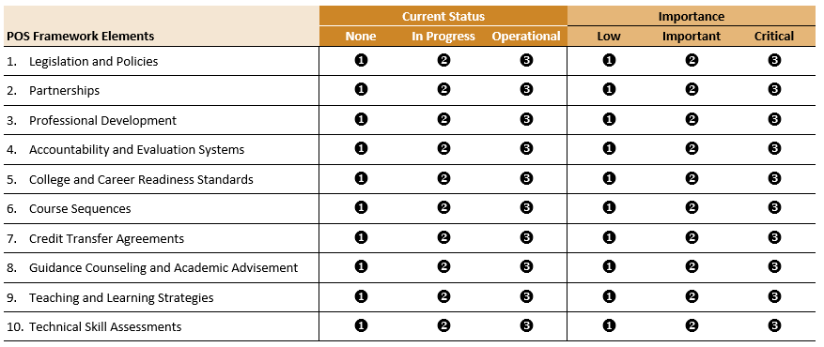

Alongside the OCTAE framework, states were given the flexibility to establish their own
criteria for approving CTE programs that qualify for federal Perkins funding support. “As a
result, programs of study offered within and among states may differ in structure because of a
lack of uniform criteria used to establish and implement a program of study.” (CTE.ed.gov.
Initiatives)
In 2013, the American Federation of Teachers and the Albert Shanker Institute released a
paper outlining their thoughts on high-quality CTE programs. With the foundation of the
OCTAE framework, the paper identified a number of essential components of high-quality CTE
programs. Programs should:
- Be aligned with the Common Core and Common Career Technical Core standards.
- Employ teaching strategies and curricula that integrate career and technical subjects, as well as core academic subjects, in students’ programs of study.
- Have as their foundation partnerships between educational institutions, on the one hand, and, on the other hand, businesses, community institutions and labor unions from all sectors of the economy, private and public, for profit and not-for-profit.
- Coordinate career and technical programs and sequences between secondary and post-secondary institutions.
- Provide educators with high-secondary high-quality professional development that is embedded in their educational workplace, focused on real issues they confront in their work and sustained over a period of time.
- Incorporate appropriate technology.
- Whenever possible, provide internships and other work-based learning opportunities for students.
- Use high quality performance assessments of technical skill.

(Albert Shanker Institute, 2013, p.3)
Associated with the release of the above paper outlining high-quality CTE programs, was
a presentation by James Stone, Director of the National Research Center for CTE. The 2013
presentation summarized the research on CTE programs and posited four elements critical to
quality CTE programs: (1) Rigorous programs and curriculum, (2) Effective pedagogy- a
systems approach aligned between levels and sectors of education, (3) Alignment with industry,
(4) Professional Development. (Stone, 2013, p.38)
In 2015, the Association of Career and Technical Education (ACTE) developed a
summary and crosswalk of the various program quality frameworks used in CTE nationally.” To
develop a rigorous definition of high-quality CTE, the ACTE staff began by examining existing
frameworks and standards developed by national education and workforce organizations and
government agencies that describe quality for CTE programs and schools, career academies,
career pathways and related initiatives.” (ACTE online, 2019, p.2) The review concluded: “while
there were many commonalities among the frameworks, there was content missing with
relevance to CTE, and generally, few sets of quality standards, directed at individual, local
programs of study.” (ACTE online, 2019, p.2) With the above analysis and feedback from focus
groups, surveys, subject matter experts, pilot testing, and correlated criteria from the above
mentioned OCTAE framework, ACTE released their own “CTE Program of Study Framework.”
The ACTE framework defines ninety-two criteria from twelve elements (listed below) of a high
quality CTE program of study.
ACTE CTE Program of Study Framework Elements
- Standards-aligned and Integrated Curriculum
- Sequencing and Articulation
- Student Assessment
- Prepared and Effective Program Staff
- Engaging Instruction
- Access and Equity
- Facilities, Equipment, Technology and Materials
- Business and Community Partnerships
- Student and Career Development
- Career and Technical Student Organizations
- Work Based Learning
- Data and Program Improvement (ACTE online, 2019, Defining Quality p.1)
A 2017 study examined the quality indicators guiding the rigor of secondary career and
technical education programs of study in the United States. The study provided a picture of state
practices in the design and review process of local secondary CTE programs of study. Xing,
Shaw and Gordon (2017) were able to locate publicly accessible secondary CTE quality program
standards for thirty-eight states. “Through content analysis we identified twelve quality elements
that conform to those of the ACTE framework, therefore, we adopted the names of those twelve
elements. In addition, we synthesized two more quality elements from the analysis of state
documents that did not fit into the ACTE framework and named them Legislation and Policies
and Program Administration.” (p. 51) Their study found the top five implemented quality
elements from across the nation were: (1) Prepared and Effective Program Staff, (2) Business
and Community Partnerships, (3) Standards-aligned and Integrated Curriculum, (4) Sequencing
and Articulation (5) Engaging Instruction.
The CTE program of study assessment and guidance tools are targeted with frameworks
and criteria in generalized terms for improvement and growth for all CTE programs of study.
Industry sector program quality guidelines have also been developed and available that coincide
with the national generalized framework elements yet speak to industry specific criteria. Program
of study frameworks alongside their supporting criteria can foster stakeholder conversation and
reflection on both the status of local readiness and capacity for implementation of proposed CTE
programs and the evaluation of current ones.
The central role of partnerships is situated in all the related documents regarding quality
CTE and the program improvement or readiness guidelines within Perkins-funded programs. The
Table 2 below is the OCTAE framework and assessment tool for CTE program partnerships.
Table 2: Partnerships Self-Assessment Ranking of Status and Importance
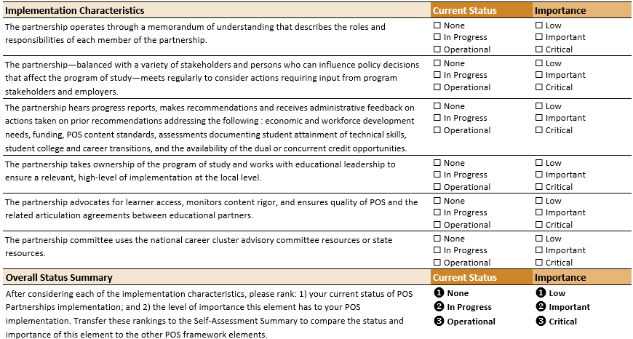

(CTE.ed.gov. Initiatives p.19)
Figure 2 below is the (ACTE online, 2018) program of study framework for business
community partnerships. (p.4)
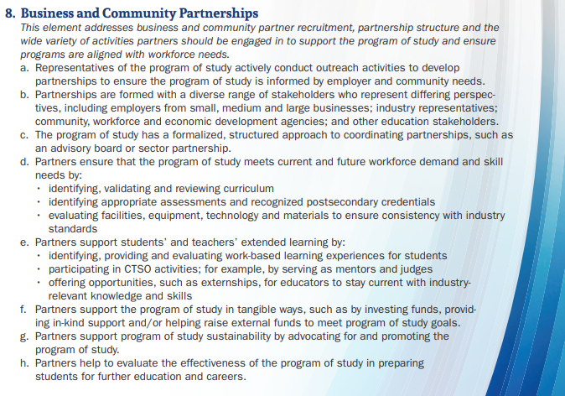
Partnership Recruitment, Structure, Activities
Figure 2. ACTE Business and Community Partnership Elements
Related to the above program of study partnership framework, key guidance is proffered aligned to the above outlined criteria.
Active outreach and recruitment strategies can ensure that programs of study are making connections that meet the diverse needs of their students and their community. Employers are far from the only partners who can and should be engaged with your CTE program of study. Engaging industry associations, programs of study can gain a more comprehensive perspective on workforce needs in the region, The advisory board or committee uses local knowledge and industry expertise to support a specific CTE program of study or program area in a school or district. (p.3) The ultimate goal of recruiting a diverse group of partners and supporting them with formalized structures is to maximize partners’ ability to contribute to a quality program of study, for the benefit of students and the workforce. (ACTE online, 2019, p.4)
The advisory board or committee is the primary mode of engagement and collaboration
between CTE programs and business and community partners. The advisory board members
provide local knowledge and industry expertise to support CTE programs of study. Advisory
committees ensure CTE program administration and program instructors remain engaged with
local advocates and industry professionals and remain abreast of industry trends and
opportunities for students. Kerka (2002) outlined the primary responsibly of an advisory
committee as: “the group develops and carries out a yearly plan of action, they articulate long-
term and short-term goals and objectives, by regularly reviewing curricula to determine if they
are meeting the needs of the students and the projected employment needs of business and
industry. (p.4)
Partnership Facilitations and Outcomes
Understanding what supporting factors are necessary for schools to develop and sustain
partnerships can alleviate struggles or barriers. (Buettner, Morrison, Wasicek, 2002), describe
what is referred to as the necessary seeds for partnership success. (1) Defined mission and goals,
(2) Overlap of partner and school activities, (3) Extension of credibility and reputation, (4) Gains
in productivity and efficiency, (5) Shared resources. (p.6)
Bryan and Henry (2012) note that “Sustainability should be a key consideration in
partnership building because a lack of sustainability can lead to partners' pessimism and
reluctance to engage in the future in what may be perceived as wasted efforts.” (p.417)
Alexander, Weiner, Metzger, Shortell, Bazzoli, Hasnain-Wynia, Sofaer and Conrad (2003)
identified five characteristics that differentiate thriving/robust partnership profiles from those
that are identified as low potential partnerships.
- Outcomes based advocacy and the sharing and celebration of the partnerships accomplishments with all stakeholders.
- Vision-focused or agreement of partners on long-term vision, goals, and actions.
- A systems orientation in which problems and solutions are seen as resulting from all systems, that is, school, families, and communities.
- Internal structure that fosters partners’ participation, develops current and new leaders, and shared roles and responsibilities.
- Community linkages with strong inclusive connections. (p.142)

Valadez and Snyder (2006) in studying partnerships across educational institutions make
recommendations for the following elements to be evident for partnership success. (1.) Mutually
agreed on partnership goals, (2.) Commitment to the partnership, (3.) Appreciating and bridging
cultural differences, (4.) Ongoing communication, (5.) Strengths of each partner recognized, (6)
Shared power in decision making and policy formation, and (7.) Ongoing evaluation. These
above elements stress the need for an organized structure of agreement and commitment to the
attainment of the partnership goals. Valdez and Snyder (2006) note that “information flow must
occur through regular formal meetings with all sectors of the partnership coming together to
share ideas and discuss issues.” (p. 45)
School-based partnerships can have both an impact on student opportunity and
motivation according to the study findings by Scales, Foster, Mannes, Horst, Pinto and
Rutherford:
Students with high partnership exposure agreed significantly more that partnership experiences had made them more interested in their regular academic classes, improved their schoolwork, and improved their problem-solving abilities and creative thinking. Students with high exposure to partnership activities also were far more likely to have discussed college with their teachers and to have talked to an adult about careers, especially to have talked about careers with a person who was already employed in a field in which the student was interested. (2005, p.170)

Partnership Barriers
Amey, Eddy and Campbell (2010) clarify important considerations regarding barriers in
partnership development. Highlighted in these points is the a priori intent, understanding and
commitment needed of the constituent individuals of the partnership. (1.) Partnerships cannot be
considered a form of compliance. (2.) Partnerships cannot be considered fringe activities. (3.)
Partnerships are difficult and complicated. (4.) Partnerships do not always fit into work
evaluation criteria. (5.) Partnerships need to operate across organizational cultures, values, and
policies that conflict.
Leadership within partnership groups should be aware of potential barriers for
continuing success. The Kentucky University Center for Community Health (2020) reports that
competition and dominance of current and potential partners should be resolved. Also noted,
was that partnership effectiveness, efficiency and coordination is realized when there
are greater links to the community and partner membership capacities of time, skill, and
resources are available.

Summary
Federal legislation in the Perkins IV and Perkins V Acts continue to encourage partnership development in CTE programs of study and have expanded provisions that require specified program involvement and alignment with a diverse range of stakeholders. As CTE programs align their capacities and quality to Perkins mandates, Federal, State and industry program evaluation framework and assessment tools have been developed and have become available. The central role of partnerships is situated in all these frameworks. The framework elements and criteria regarding partnership quality typically correspond to partnership recruitment, structure, and activities. Awareness to the supporting factors and possible barriers to partnership development are necessary to ongoing program success. The correspondent studies in this review highlight that quality CTE partnership constructs are system level developed, ongoing process oriented and include a diverse range of stakeholders and activities. This literature review highlights the critical element of school-based partnerships in quality CTE program development and student success.

Chapter 3.
Methodology Introduction
A critical element in the success of Career Technical Education (CTE) programs are
ongoing relationships with industry and community stakeholders. CTE programs require
collaborative partnerships aligned to industry and community need that provide identification,
validation and currency of technical and workforce readiness skills required of students. These
CTE partnerships are enhanced and sustained through a systematic and ongoing development
process of recruitment, engagement, and evaluation. CTE programs share a common challenge in
their efforts to develop and strengthen their partnerships. Partnerships are not easy to cultivate
and sustain. This study will explore the relationship of factors that are complimentary or
needed to the development of high-quality partnership profiles in CTE.
Research Questions
The research questions of this study are oriented to the facilitating factors or needs in
CTE partnership development that accomplish or diminish important criteria necessary in high
potential partnership profiles. The research questions for this study will evaluate CTE programs
of study by relating accomplished partnership criteria in juxtaposition to reported factors
facilitating or needed regarding that criteria.
The following questions are to be answered during the study:
- To what degree are the elements used as criteria for the ACTE High Quality CTE Program of Study Framework/Partnerships (ACTE HQP) evident in local CTE programs?

- What are the facilitating supports and what is needed in recruiting a diversity of stakeholders in CTE programs of study.

- What are the facilitating supports and what is needed in developing coordinating partnership structures in CTE programs of study.

- What are the facilitating supports and what is needed to ensure CTE partners participate in a wide range of collaboration and participation?

- What are the facilitating supports and what is needed for CTE partnership student interaction and exposure?

- Does the number of years a CTE teacher has worked in the career field prior to teaching have an impact on their partnership profile?

- Does the number of years teaching CTE have an impact on program partnership profiles?

- Does the type of industry program of study have an impact on program partnership profiles?
Research Design
This study will explore the numerous factors related to the ability of CTE teachers to
develop thriving robust partnership profiles from those that are seemingly of low potential.
This research study uses a non-experimental design method as the variables are as reported and
not manipulated. The type of research is a mixed method convergent design from reported data
and responses collected from surveyed CTE teachers in Wicomico County Maryland. The survey
questions are structured and the point of analysis is at the integration of the qualitative and
quantitative responses that follow immediate to each other. This research will be explanatory in
elaborating the causal qualitative partnership support themes that interface with the evidentiary
ordinally ranked criteria data set values. “Explanatory sequential designs are used when the
purpose of the study is to elucidate, elaborate on, or explain quantitative findings.” (McMillan
2016, p 373) The data sets are mean “u” and standard deviation “SD” response values from
Likert scale reporting in areas of partnership recruitment, organizing partnership structures,
partnership activities, and partner student engagement. Instructor categorical years of teaching,
industry experience and program of study industry category will be surveyed and compared to
the partnership individual criteria mean scores for comparative analysis.
The juxtaposition of the partnership support/need themes with the reported partnership
criteria data positions will provide overall evidence to supporting factors in theory necessary
for high quality CTE partnership profiles
Population and Sample.
The population from which this study samples are the secondary CTE program of study
instructors (POS) in Maryland. The majority of Maryland school districts support ten or more
CTE career clusters with numerous programs of study within each. (Maryland State Department
of Education, 2019) The sample for this study is the CTE district in Wicomico County Maryland.
Wicomico County CTE programs reside at four different high schools. There are thirty-eight
instructors to be surveyed that comprise ten career clusters and twenty-five CTE POS. There are
thirteen CTE programs of study that have multiple instructors. Of the twenty-five Wicomico
CTE POS surveyed, twenty-one have established program advisory committees (PAC). The
program PAC committees are members of industry and community that support programs in
various or multiple ways. As of 1/30/2021 there were three hundred and seventy reported PAC
members aligned to Wicomico CTE programs of study.
Study Variables
Dependent Variables
The dependent variables of this study are nine partnership criteria postures as developed
in CTE programs of study. The first dependent variable is the responses quantified by CTE
instructors in measures of partnership recruitment and the diversity of stakeholders engaged.
The second dependent variable is the responses quantified regarding structures in place to
involve and coordinate ongoing and organized participation with involved partners. The third
dependent variable is the responses quantified regarding the array of activities that relate to
partnership involvement to ensure overall program success. These activities include: reviewing
standards, evaluating activities, program investment, program advocacy, and program evaluation.
The fourth dependent variable is the responses quantified regarding the level of student exposure
and interaction with program partners.
Independent Variables
Independent demographic variables of instructors number of years teaching, number of
years involved with industry before teaching, and program of study industry category will be
studied for possible impacts on partnership criteria.
Confounding Variables
The relative fidelity of CTE district supervisors toward the forging of partnerships can
impact individual programs of study and district wide partnership profiles. Other variables could
include how often industry advisory boards meet, relationships of instructors to industry
members, economic strength of industry sectors within local area, gender of teacher, ethnicity
of teacher, level of education of teacher and partners, and continuity of instructional goals.
Table 3: Study Variables
Variable Name | Type | Measure | Scale
Partnership Recruitment and Diversity of Stakeholders | Dependent | Partner Recruitment and Diversity of Partners | Continuous Likert Scale
Partnership Coordinating Structures | Dependent | Partnership Structure and Organization | Continuous Likert Scale
Partner Activities:  Reviewing standards  Evaluating activities  Program investment  Program advocacy  Program evaluation | Dependent | Partnership Activities | Continuous Likert Scale
Partner Student Engagement | Dependent | Student Engagement  with Partners | Continuous Likert Scale
Instructor Years of CTE Teaching | Independent | Reported Years Teaching | Continuous
Instructor Years in Career Before Teaching | Independent | Reported Years in Teaching | Continuous
Program of Study Industry Category | Independent | Reported Program of Study Category | Categorical

Instrumentation
The survey for this study was created in Survey Monkey by the researcher. The first
question of this sixteen-question survey will require an acknowledged yes for consent (yes/no)
before progressing to the survey. The survey has nine Likert scale partnership criteria-based
questions, three open-ended questions related to instructor partnership supports and needs, and
three questions asking for instructor years teaching in CTE, years in profession before CTE
teaching, and industry identification of program of study.
Instructor Partnership Survey
Evaluation Criteria:
(1 = Not at all achieved)
No evidence of the criteria in your program of study.
(2 = Minimally achieved)
The criteria is minimally implemented in your program of study.
Implementation is just beginning.
Evident infrequently.
Implementation is in small portion of program of study.
Access limited to a small segment of students.
(3 = Moderately achieved)
The criteria is evident in your program of study, but implementation is uneven and not on a sustained and regular basis.
Access is available to most, but not all, students.
(4 =Substantially achieved)
The criteria has been fully implemented throughout your program of study.
All parts of criteria are evident.
Implementation is evident on a regular and sustained basis
Implementation is evident across all portions of your program of study
Access is available to all students.
The questions in this section are related to your industry experience, years teaching and program identification.
2. What are the number of years you had worked in the career field prior to teaching in your program of study?
(1. 0-5
(2. 6-10
(3. 11-15
(4. 16-20
(5. More than 20
3. What are the number of years you have been teaching in your program of study?
(1. 0-5
(2. 6-10
(3. 11-15
(4. 16-20
(5. More than 20
4. From the four categorical options below where would your CTE program of study be situated?
(1. Auto and Construction Trades
(2. Health, Education and Human Services
(3. Media and Computer Sciences
(4. Business and Related Sciences
The statement and questions in this section ask for you honest opinion regarding partnership recruitment efforts. Please do not use names.
5. Representatives of your program of study actively conduct outreach activities in developing partnerships to ensure your program is informed by employer and community need.
(1 = Not at all achieved)
(2=Minimally achieved)
(3=Moderately achieved)
(4=Substantially achieved)
6. Partnerships are formed with a diversity of stakeholders who represent differing perspectives, including industry representatives, community members, and education stakeholders.
(1=Not at all achieved)
(2=Minimally achieved)
(3=Moderately achieved)
(4=Substantially achieved)
The statement and questions in this section ask for your honest opinion regarding partnership structures that coordinate your support. Please do not use names
7. Your program of study has a formalized, structured approach to coordinating partnerships, such as an advisory board or industry sector partnership.
(1=Not at all achieved)
(2=Minimally achieved)
(3=Moderately achieved)
(4=Substantially achieved)
8. Regarding partnership structures and recruiting efforts. What are your supports and how are individuals involved? What is needed? Please explain.
The statement and questions in this section ask for your honest opinion regarding partnership activities. Please do not use names.
9. Partners ensure that your program of study meets current and future workforce demand and consistency with industry standards.
(1=Not at all achieved)
(2=Minimally achieved)
(3=Moderately achieved)
(4=Substantially achieved)
10. Partners support your students and extended learning by: identifying, providing, and evaluating experiences for students.
(1=Not at all achieved)

(2=Minimally achieved)

(3=Moderately achieved)

(4=Substantially achieved)
11. Partners support your program of study in tangible ways, such as investing funds, helping to raise external funds, providing in-kind support i.e. providing classroom instruction or support for student projects.
(1=Not at all achieved)
(2=Minimally achieved)
(3=Moderately achieved)
(4=Substantially achieved)
12. Partners support the sustainability of your program of study by both advocating for and promoting it.
(1=Not at all achieved)
(2=Minimally achieved)
(3=Moderately achieved)
(4=Substantially achieved)
13. Partners help to evaluate the effectiveness of your program of study in preparing students for further education and career.
(1=Not at all achieved)
(2=Minimally achieved)
(3=Moderately achieved)
(4=Substantially achieved)
14. Regarding Partnership Activities. What are your supports and how are individuals involved? What is needed? Please explain.
The questions in this section ask for your honest opinion regarding student and partnership exposure and interaction.
15. Your program of study provides numerous opportunities for students to interact with industry and program partners.
(1=Not at all achieved)
(2=Minimally achieved)
(3=Moderately achieved)
(4=Substantially achieved)
16. Regarding student exposure and interaction with partners. What are your supports and how are individuals involved? What is needed? Please explain.
Table 4: Research Question Data Source
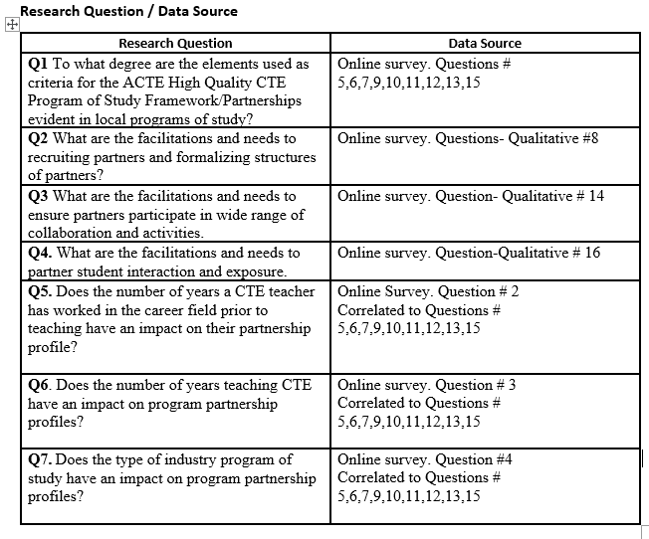
Data Collection
The surveys will be available to participants by using a weblink to SurveyMonkey. IP
address tracking will be disabled through SurveyMonkey. The survey link will be simultaneously
sent to email addresses of all CTE instructors in Wicomico County, Maryland. These email
addresses are provided by the Wicomico County CTE supervisor. The email addresses will not
be saved or entered on the SurveyMonkey website. Once the survey data is downloaded to Excel,
the individual surveys will be destroyed.
The emails have an explanation regarding the overall survey, the option to participate,
and the participation requirement of acknowledging the consent statement. (See appendix)
One week subsequent to initial email survey request, a follow-up email thanking respondents
and a reminder for those who have not will be sent.
Analysis of Data
The data collected from the survey instrument will be a series of Likert Scale criteria
based inputs followed by qualitative responses. Individual respondent totals from the nine
criteria will be analyzed and the distributive statistics of mean, median, mode and standard
deviation reported and charted.
The three quantitative independent variable questions regarding years teaching, years
in career field, and teacher program of study will each be charted in group frequency
distributions. These variables will use the One Way Anova test statistic to evaluate group
population means, standard deviation, F stat, and P value.
Representative major themes of defined partnership facilitating factors and needs
for each years of experience category and program of study industry category will be charted.
The integration of the quantitative partnership data sets with the qualitative responses will
use a traditional grounded theory method of analysis.
Grounded theory (GT) is a structured, yet flexible methodology. This methodology is appropriate when little is known about a phenomenon; the aim being to produce or construct an explanatory theory that uncovers a process inherent to the substantive area of inquiry. One of the defining characteristics of GT is that it aims to generate theory that is grounded in the data. (Chun, 2019)
The three qualitative partnership responses will evolve with initial coding of the responses
looking for similarities and differences and then labeled. Secondly, these initial coding
dimensions will be categorized around core concepts. These core concepts will be charted for
discussion. The core concepts derived will be aligned to representative groups of partnership
facilitating factors or need factors. Finally, these core concepts alongside the criteria data will be
integrated for interpretation and a thick description of meaningful storylines of partnership
facilitations and barriers will be developed. “A thick description is an explanation that includes
both the behavior and the context in which the behavior was displayed.” (Bui, 2014, p. 185.)
Participant quotations will represent major themes and the survey participant perspectives for
discussion.
Summary
The research questions for this study evaluate CTE programs of study by relating
accomplished partnership criteria to reported factors of facilitation and need regarding that
criteria. The research questions ask participants for both quantitative and qualitative responses to
their postures in important areas of partnership development. The survey will use a mixed
method convergent design from reported data and responses. This research will be explanatory in
elaborating the causal partnership support or need themes that interface with ranked criteria data
set values. The population represented in this study are the CTE program of study instructors of
Maryland. This study samples the CTE instructors in Wicomico County Maryland.
The dependent variables of this study are nine partnership criteria postures as developed
in CTE programs of study. The independent variables of this study are the CTE instructors
years in the career field, years teaching, and program of study industry category. The survey has
nine scaled partnership criteria-based questions, three open-ended questions related to instructor
supports and needs, and three questions regarding instructor years of teaching, career
professional experience and categorical industry profile of instructors program of study. The
data will be collected by email survey. The analysis of the data will be from the criteria based
quantitative summaries and the integrated adjoining explanatory qualitative response themes.

Chapter 4.

Introduction
The purpose of this study as explained in previous chapters has been to evaluate the
relative strength in partnership development in local Career Technical Education (CTE)
programs. CTE programs share a common challenge in their efforts to develop and strengthen
their partnerships. Partnerships are not easy to cultivate and sustain. As CTE programs align new
and existing programs with college and career ready standards, CTE program engagement with
schools, communities, industry, and post-secondary institutions is increasingly necessary. With
the potential availability of CTE partnership resources and the willingness and capability of CTE
programs to utilize them, this study has explored the current profiles of partnership development
within an CTE district. Specifically, this study has elucidated the current status, needs and
facilitations used that sustain the network of CTE partnerships in the district participating in this
study. A survey was developed and distributed to 38 CTE programs of study with 30 instructors
responding. Included in this chapter are the descriptive statistics regarding demographics of the
participants and the study measures associated with alignment to partnership criteria. Teacher
perceptions regarding facilitating supports and needs follow these statistics on partnership
recruitment, activities, and student engagement. The themes included all responses and the
designate numbers in times they appeared. All teachers responded at least once to the three
extended questions regarding facilitating support and need. This chapter concludes with the
partnership criteria statistics discussed in depth related to the research questions on partnership
attainment profiles.
The descriptive demographic statistics of the study participants are presented below in
frequency and percentages of respondents in Table 1,2,3. The teacher program of study data in
Table 1. was categorically organized associated to contiguous aspects of how programs relate
and collaborate jointly in such aspects has program planning, budgeting, and student activities.
The largest percentage of respondents are associated categorically with health, education and
human services (43%) (Table 5), greater than 20 years in the career field (27%) (Table 6), and
greater than twenty years teaching (27%) (Table 7).
Table 5: Teacher Program of Study- Frequency and Percent.
Characteristic | Frequency | Percentage of Respondents
Group One: Health, Education, Human Services | 13 | 43
Group Two: Auto, Construction | 8 | 27
Group Three: Media, Computer Sciences | 4 | 13
Group Four: Business and Related Sciences | 5 | 17

Table 6: Teacher Years in Career Field Prior to Teaching- Frequency and Percent.
Characteristic | Frequency | Percentage of Respondents
0-5 | 6 | 20
6-10 | 7 | 23
11-15 | 4 | 13
16-20 | 5 | 17
> 20 | 8 | 27

Table 7: Teacher Years Teaching CTE, Frequency and Percent.
Characteristic | Frequency | Percentage of Respondents
0-5 | 5 | 17
6-10 | 7 | 23
11-15 | 6 | 20
16-20 | 4 | 13
> 20 | 8 | 27

Research Question # 1 To what degree are the elements used as criteria for the ACTE High Quality CTE Program of Study Framework/Partnerships (ACTE HQP) evident in local CTE programs?
The respondent data in Table 8 describes the study population (n=30) achieved
cumulative scores associated with nine partnership elements. The cumulative partnership value
for all criteria was (M=2.90, SD=.82). The means range was tightly patterned on all nine
elements from M=2.7-M 3.13. The partnership elements with the highest values were the
structuring of partnerships (M=3.13, SD= .99), and evaluation of standards (M= 3.13, SD= .88).
The partnership elements with the lowest values were partnership activities in providing tangible
investments in securing classroom materials or project support (M=2.70. SD=1.06), and direct
engagement with students (M=2.73, SD=.89). The total population (n=30), M distribution
intervals are represented in Figure 3. 74% of respondents achieved =/> (M=2.6).
Research Question # 1 To what degree are the elements used as criteria for the ACTE High Quality CTE Program of Study Framework/Partnerships (ACTE HQP) evident in local CTE programs? Note: (1 = Not at all achieved) (2=Minimally achieved) (3=Moderately achieved) (4=Substantially achieved)

Table 8. Partnership Element Mean Totals

Partnership Element | Mean | SD | Mode | Median | Range | N
Partnership Outreach | 2.93 | .77 | 3 | 3 | 2-4 | 30
Diversity of Stakeholders | 3.03 | .85 | 3 | 3 | 1-4 | 30
Partnership Structure | 3.13 | .99 | 4 | 3 | 1-4 | 30
Evaluation of Standards | 3.13 | .88 | 4 | 3 | 1-4 | 30
Identifying, Providing,  Evaluating, Student  Experiences | 2.96 | .91 | 3 | 3 | 1-4 | 30
Tangible Investment,  Classroom Project Support | 2.70 | 1.06 | 4 | 3 | 1-4 | 30
Promote and Advocate  Program | 2.96 | .91 | 3 | 3 | 1-4 | 30
Evaluate Program Effectiveness  Program Preparing Students | 2.83 | .96 | 3 | 3 | 1-4 | 30
Engagement with Students | 2.73 | .89 | 2 | 2.5 | 1-4 | 30
Total Criteria Mean Values | 2.90 | .82 | 2.66 | 2.88 | 1.4-4 | 30

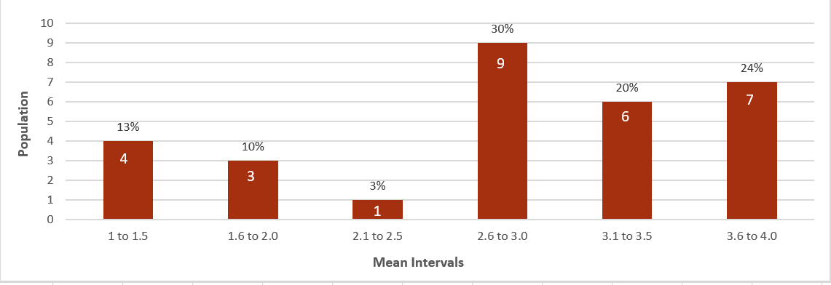
Figure 3. Mean Distribution Partnership Criteria Totals (N 30)

Research Question # 2. Regarding partnership structures and recruiting efforts. What are your supports or how are individuals involved? What is needed?
The respondent data in Table 9. describes the study population (n=30) achieved
cumulative scores associated with facilitating supports and what is needed in outreach and
recruiting a diversity of stakeholders and structuring support in CTE programs of study.
Additionally, Table 9. includes the concurrent qualitative response themes associated to this
criteria. The achieved totals related to this criteria were (M=2.86, SD=.80). The most related
response need associated to this criteria was the lack of time provided to recruit partners. (5) The
most related partnership facilitating factor was that the current status of the program of study
partnership individuals was satisfactory. (4) The greatest reported need was time to recruit (5).
Research Question # 2 Regarding partnership structures and recruiting efforts. What are your supports or how are individuals involved? What is needed? Note: (1 = Not at all achieved) (2=Minimally achieved) (3=Moderately achieved) (4=Substantially achieved)
Table 9: Partnership Structures and Recruiting Efforts Mean/Themes
Partnership Elements | Mean |  | SD | Mode |  | Median | Range | N
Partnership Outreach + Diversity | 2.86 |  | .80 | 3 |  | 3 | 1-4 | 60
Themes Emerged from Teacher Narratives |  | #  Responses |  |  | Definition
- Workforce Coordinator Recruiter Needed |  | 2 |  |  | Workforce Coordinator could establish ties with community on behalf of teachers.
- Lack of Time to Recruit |  | 5 |  |  | Teachers lack necessary time to establish community relationships.
+ Industry Partners Sufficient |  | 4 |  |  | Relationships with current industry partners satisfactory.
+ Maintaining Relationships Important |  | 3 |  |  | Teachers broaden their portfolio of partners by maintaining them and using them to recruit.
+ PAC Meetings Organization. |  | 3 |  |  | Program Advisory Council dinner and meeting is scheduled and planned by CTE Staff.
- Beginning Teacher Overwhelmed |  | 1 |  |  | Beginning teacher not familiar with Partnership structuring.
- Lack time for Individual meetings |  | 3 |  |  | Teachers lack time to meet individually with partners.

Research Question #3. Regarding partnership activities. What are your supports or how are individuals involved? What is needed?
The respondent data in Table 10. describes the study population (n=30) achieved
cumulative scores associated with partnership activities. These scores are cumulated from five
areas associated with partnership activities. Additionally, Table 10 includes the concurrent
qualitative response themes associated to this criteria. The achieved totals related to this criteria
were (M=2.92, SD=.96). The most related response need associated to this criteria was lack of
teacher experience in coordinating expanded involvement of partners in diverse range of
activities. (2) The most related partnership facilitating factor was the willingness of partners to
participate in program activities. (5)
Table 10: Partnership Activities Mean/Themes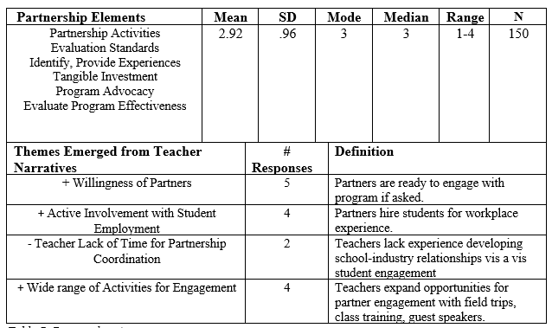

Research Question #4 Regarding student exposure and interactions with partners. What are your supports and how are individuals involved? What is needed? Please explain.
The respondent data in Table 11. describes the study population (n=30) achieved
cumulative scores associated with partnership activities. These scores are cumulated from five
areas associated with partnership activities. Additionally, Table 11 includes the concurrent
qualitative response themes associated to this criteria. The achieved totals related to this criteria
were (M=2.73, SD=.89). The most related response need associated to this criteria was lack of
time (4), and teacher experience in coordinating expanded involvement of partners in diverse
range of activities. (3) The most related partnership facilitating factor was the willingness of
partners to participate in program activities. (8)
Research Question #4 Regarding student exposure and interactions with partners. What are your supports and how are individuals involved? What is needed? Please explain Note: (1 = Not at all achieved) (2=Minimally achieved) (3=Moderately achieved) (4=Substantially achieved)
Table 11: Partnership Student Interaction Mean/Themes
Partnership Elements | Mean |  | SD | Mode |  | Median | Range | N
Student Exposure Interaction  w/ Partners | 2.73 |  | .89 | 2 |  | 2.5 | 1-4 | 30
Themes Emerged from Teacher Narratives |  | #  Responses |  |  | Definition
+ Willingness of Partners to Engage w/ Students |  | 8 |  |  | Partners are ready to engage with students if asked.
-Students not ready for interface with partners |  | 1 |  |  | Students have behavioral and learning issues.
- Businesses lack interest. |  | 2 |  |  | Businesses lack interest in working directly with schools/students
+ Universities and Partners visiting schools and classrooms |  | 5 |  |  | Students learn about post-secondary opportunities in career field through visits from university
+ Worksite relationships |  | 4 |  |  | Students gain exposure and interaction with onsite experiences.
- Few interactions scheduled /organized |  | 3 |  |  | Teachers schedule few opportunities for industry/student engagement.
- Lack of time |  | 4 |  |  | Teachers lack time to coordinate visits from partners or for students to visit them.
- Lack of Transportation |  | 2 |  |  | Students lack ability to visit or accept job experiences because of transportation issues.

Research Question #5 Does the number of years a CTE teacher has worked in the career field prior to teaching have an impact on their partnership profile?
The respondent data in Table 12 and Figure 4 describes the study population (n=30)
achieved cumulative scores associated with the categorical number of years instructors spent in
the related industry before teaching CTE. The highest score (M=3.39, SD=.52) was in the >20-
year group five. The lowest score (M=2.66, SD 1.17) was in the 0-5-year group. The One Way
Anova F-Stat of 1.406 relates a relative low quotient in the sum of the squares difference
between the groups and the squares of the groups themselves. The null hypothesis is that there is
no impact on partnership profiles as related to the number of years in the career field. The null
hypothesis is correct as the F-Stat = 1.4069 and (P=.2606). The correlation (r = .3837) of the
mean years in career field group partnership scores was moderately positive.
Research Question #5 Does the number of years a CTE teacher has worked in the career field prior to teaching have an impact on their partnership profile? Note: (1 = Not at all achieved) (2=Minimally achieved) (3=Moderately achieved) (4=Substantially achieved)
Table 12: Teacher Years in Career Field Group Criteria Values.
Years in Career Field | Mean | SD | Mode | Median | Range | N
Group 1 0-5 | 2.66 | 1.17 | None | 25 | 13-35 | 6
Group 2 6-10 | 3.01 | .56 | 29 | 29 | 18-35 | 7
Group 3 11-15 | 2.49 | .41 | None | 24.5 | 17-30 | 4
Group 4 16-20 | 2.54 | .41 | 14 | 22 | 14-36 | 5
Group 5 > 20 | 3.39 | .52 | 26 | 28.5 | 24-36 | 8
Note: One-Way Anova: Sum of Squares 19.55 F-Stat 1.406 P-Value .2606
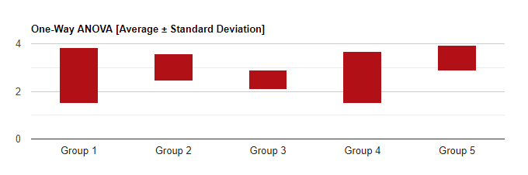
Fiqure 4. Number of Years in Career Field: Criteria Average +/- SD

Research Question #6 Does the number of years teaching CTE have an impact on program partnership profiles?
The respondent data in Table 13.and Figure 5 describes the study population (n=30)
achieved cumulative scores associated with the categorical years the CTE teachers has spent
teaching. The highest score (M=3.05, SD=1.0) was in the 16-20-year category. The lowest score
(M=2.70, SD .83 was in the 0-5-year group. The null hypothesis is that there is no impact on
partnership profiles as related by the number of years in the teaching. In this case we would
accept the null hypothesis. The One Way Anova F-Stat of .1913 relates a relative low quotient
in the sum of the squares difference between the groups and the squares of the groups
themselves. Likewise, the (P=.940) relates that there is not strong evidence to reject the null
hypothesis. The correlation (r = .27) of the mean years teaching group partnership scores was
near zero.
Research Question #6 Does the number of years teaching CTE teacher have an impact on partnership profiles. Total Partnership Mean Criteria Values. Note: (1 = Not at all achieved) (2=Minimally achieved) (3=Moderately achieved) (4=Substantially achieved)
Table 13: Teacher Number of Years Teaching CTE: Group Criteria Values
Years of Teaching CTE | Mean | SD | Mode | Median | Range | N
Group 1 0-5 | 2.70 | .83 | None | 25 | 13-34 | 5
Group 2 6-10 | 3.04 | 1.0 | None | 29 | 14-36 | 7
Group 3 11-15 | 2.86 | .83 | None | 26 | 18-36 | 6
Group 4 16-20 | 3.05 | .43 | None | 26.5 | 24-33 | 4
Group 5 >20 | 2.71 | 1.02 | None | 29.5 | 14-36 | 8
Note: One-Way Anova: Sum of Squares 19.25 F-Stat .1913 P-Value .940
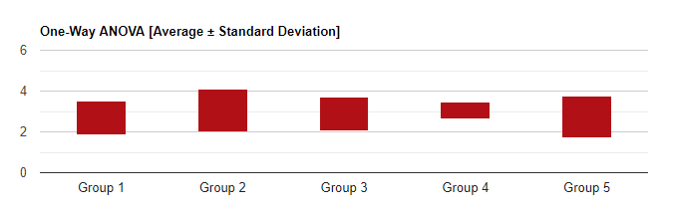
Figure 5 Years Teaching. Group Criteria Average +/- SD
Research Question #7 Does the general industry type of CTE program of study have an impact on program partnership profiles?
The respondent data in Table 14.and Figure 6 describes the study population (n=30)
achieved cumulative scores associated with the categorical industry program of study. The
highest score (M=3.54, SD=.46) was in the Health, Education, and Human Services category.
The lowest score (M=2.06, SD .54 was in the Business and Related Sciences. The null
hypothesis is that there is no impact on partnership profiles as related to the program, of study
The One Way Anova F-Stat of 19.55 relates a significantly high quotient in the sum of the
squares difference between the groups and the squares of the groups themselves. Likewise, the
(P=.00004) relates that there is strong evidence to reject the null hypothesis.
Research Question #7 Does the type of industry program of study have an impact on program partnership profiles? Total Group Partnership Mean Criteria Values. Note: (1 = Not at all achieved) (2=Minimally achieved) (3=Moderately achieved) (4=Substantially achieved)

Table 14. Industry Program of Study: Group Criteria Values
Industry Program of Study | Mean | SD | Mode | Median | Range | N
Group One: Health, Education, Human Services | 3.54 | .46 | 36 | 30 | 24-36 | 13
Group Two; Auto, Construction | 2.77 | .62 | None | 28.5 | 17-35 | 8
Group Three: Media, Computer Sciences | 2.13 | .74 | None | 19 | 13-26 | 4
Group Four: Business and Related Sciences | 2.06 | .54 | None | 18 | 14-25 | 5
Note: One-Way Anova: Sum of Squares 19.55 F-Stat 12.07 P-Value .00004

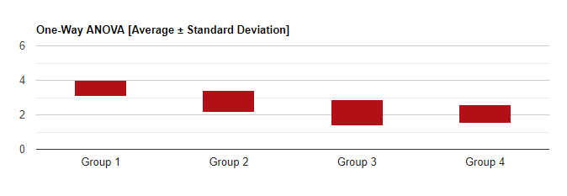
Figure 6. Teacher Program of Study CTE Group Criteria Average +/- SD
Summary:
Research question #1 and the evidentiary partnership element profiles for the
total sample group and the associated nine partnership elements suggests key understandings.
The data in Figure 1 suggests that there is a differentiated strata of partnership criteria
attainment in the total population. Seventy-four percent of respondents scored (=/>) 2.6
cumulative Mean Scores and the balance except for one individual scored (=/<) 2.0. Across all
elements of partnership criteria (Table 8) there are closely arranged mean scores (2.70-3.13) yet
large standard deviations (.77-1.06), and ranges (1-4). The relative lower partnership element
scores (Classroom project support 2.70, Engagement with Students 2.73) suggests that programs
of study in this district have higher proficiency in recruiting, structuring and advisory statures
from partners than direct personal interface with instruction and students.
Regarding the emerged themes from the three open ended responses to needs and
facilitations in partnership recruitment/structuring, partnership activities, and student interaction
there were 65 direct responses.
Table 15: Years Teaching/ Theme Response #’s (n=65)
Years of Teaching CTE | Population % | % of Responses
Group 1 0-5 | 17 | 5
Group 2 6-10 | 23 | 11
Group 3 11-15 | 20 | 27
Group 4 16-20 | 13 | 23
Group 5 >20 | 27 | 34

The data above relates a low comparative response ratio to the total for teachers in the two years
teaching groups (</=) 10 years. The data suggests that teachers with lower experience levels
can have harder time articulating or coordinating their thoughts regarding partnership needs, and
facilitations. The related need associated to all three open-ended questions was the lack of
time appropriated and needed to establish, develop, and engage partners. (14 Responses). The
related partnership facilitating factor most mentioned was the overall willingness of partners to
engage in CTE programs and student support. (16 Responses) The data here suggests that CTE
programs that have had the time and ability to invest in partnership development have a willing
community of support. The group mean criteria values suggested from this study is that the
industry program of study has the highest linkage to partnership criteria profiles. This data
suggests that these industry group programs of study (Table 14) (Health, Education, Human
Services 3.54) (Auto, Construction 2.77) have partnership orientations that could be potentially
capitalized by other CTE partnership groups.

Chapter 5.
Introduction.
Community and industry partnerships are critical to the success of Career Technical
Education Programs. (CTE) Federal, state, and local policies in addition to standards and
frameworks related to CTE quality all recognize that partnerships are integral in delivering
quality CTE programs. The data analysis in the previous chapter and the correspondent studies of
this research paper highlight that CTE partnership realities and profiles are constructs of
development, are ongoing process-oriented, and include a diverse range of performance
levels. Industry and community stakeholders and their associated activities with CTE programs
of study are key determinants of CTE program success. The analysis in the previous chapter
highlights that there is capacity for improved development in partnership potentials in CTE
programs of study.
This study of CTE district partnership profiles has identified four major findings (1)
Levels of partnership orientation and development both in individual programs and industry
generalized categorical programs of study have stratified partnership accomplishments. (2) There
is a lack of needed time allotted for instructor and partner interface. (3) There are barriers to
direct partner and student interface. (4) There is a willingness and active support from partners
when developed and coordinated. Possible limitations in this study would consider that particular
elemental partnership aspects were adrift as this study and survey took place after a year of
COVID related school disruptions. However, approximately a third of the study participants
mentioned their responses reflected before COVID partnership realities. Additionally, there was
strong response numbers in direct open-ended thoughts. CTE programs of study with a diversity
and matrix of partnership support would be assuring program continuity and student opportunity
through period of abrupt and directional change.
Conclusion.
Research Question 1.
Evaluated in this study were the partnership postures of CTE programs of study across
nine partnership criteria as reported by the associated program of study instructors. The first set
of criteria included partnership outreach, diversity, and partnership structuring. The second set of
criteria included partnership activities associated with evaluation of standards, providing student
experiences, investment in project support, promotion and advocacy of programs, and program
evaluation. The third criteria included direct engagement with students. The standing across all
element values for all programs resides below moderately achieved. As reported, the total
population projected large deviations and ranges within each partnership element. However,
these large variances were generally attuned by the distributed totals from individual respondent
scores rather than the inherent stature of the element itself. Evident in this study was that if
CTE programs of study have strong orientations in outreach and structuring they have as well
strong values across the other dimensions in partnership activities. In this regard it is worth
noting a quote from ExcelinEd.org “The reason for and manner by which stakeholders are
identified and engaged sets the stages for how well the overall CTE effort meets its goals in a
timely fashion and with minimal setbacks.” (ExcelinED.org, 2018, p.7) The opposite is also
evident that if CTE programs of study are not yet oriented to an ongoing process of outreach and
recruitment this is reflected in all other partnership elements. This reality of partnership
orientation stratifies the partnership evidentiary achievement distributions, with a large segment
of programs of study realizing partnership potentials and a smaller quartile(s) minimally
achieving success. Across all partnership elements for moderately and substantially select
achieving programs, was a static accomplishment disrupted only by the partnership criteria
positions in partner investment in classroom projects and partner direct engagement with
students.
Research Question # 2
Active outreach and recruitment strategies ensure CTE programs of study are making
connections in their community that meet the needs of their program and students. Recruitment
and structuring partner participation in CTE programs is a networking and development
function toward engaging current partners and forging new relationships. An important finding
that emerged from this study is that CTE program instructors have a lack of time or the support
of coordination to engage with their current partners and to establish new community
connections. All respondents residing in the lower accomplished partnership profiles related this
concern. These “time” concerns ranged from overwhelmed to lack of time to meet with already
established partners. As with many of the partnership elements considered in this study, once
these relationships are prioritized, forged and structured, the maintenance of these relationships
becomes the priority with accumulated benefits. These accumulated benefits reside not only in
the created synergy of building a network of partners but also in all the partnership activity
elements.
Research Question #3
In this study, CTE program of study partnership activity profiles reside generally in three
stations. (1) lack of coordinated engagement, (2) workplace direct focus and coordination, (3)
student engagement and partner interaction focus. The lack of coordinated partner engagement
and teacher availability or experience in recruitment diminishes numerous elements of
partnership support. In the workplace focused partnership profiles the support themes of
workplace experience, evaluation of standards, and program effectiveness were dominant. In the
student engagement and partner interaction profile, the expanded support themes resided with
partners identifying and providing larger community interactions and experiences. The response
themes from this research question not surprisingly came from those with established networks
of support. Two significant highlights emerge from this question. The first is that partners are
willing and ready to engage across multiple partnership activity levels. The second is that
program instructors at all partnership profiles remain frustrated with lack of time for activity
coordination.
Research Question #4
Direct student interaction with community and industry members creates horizons of
understanding and opportunity. Students gain career and post-secondary directional knowledge
and expanded opportunity for workplace experience. Community and industry members have
opportunity to guide the interests of students and meet potential future students or employees.
(Scales, et.al. 2005) provides substantive conclusions that current CTE students obtain
improved academic and vocational interest with direct contact with larger community. The
majority of the partner-student engaged themes resided in the worksite relationships and visits
from post-secondary institutions. Not unlike the other research questions, lack of time for
student-partner coordination emerged here. Likewise, the willingness of partners to engage
with students when asked was predominantly noted. There was a paucity of responses associated
with partner direct instructional support and student project and community engagement. It is
unclear from this question and associated responses what directly influences these varying
approaches or to what degree are possible barriers impeding developing opportunities for
in class student-partner interface.
Research Question #5
This research has shown that the number of years a teacher works in the career field does
not generally impact partnership profiles. Evidentiary partnership criteria attainments resided
above others in the greater than twenty years in the career field category. Regarding this detail, it
is impractical to assume this is significant as all other categorical years in the career field groups
show categorical partnership criteria correlation trends.
Research Question #6
This research has shown that the number of years teaching CTE does not generally
impact partnership profiles. The research indicated that there is categorically a large variance
within the years teaching categories with the lowest partnership accomplishments expectedly in
the under five-year category but also surprisingly in the greater than twenty years teaching
category.
Research Question #7
This research indicates that the associated type of CTE industry program of study
significantly impacts partnership profiles. From a partnership criteria standpoint, the CTE
programs of study associated with current workplace opportunities in health care and services,
including auto and construction trades distanced the other partnership groups significantly
in media, computer science and business-related sciences. Seemingly, these coordinated
possibilities in the workplace for students has been developed, structured and solidified with
ongoing collaboration.
Implications for Education
CTE programs of study and their correspondence in partnership with community
stakeholders has important implications. The findings from this study and its implications are
situated in the three general profiles referenced from the criteria data and the response themes
from this study: (1) Partnership/Workforce Coordinated, (2) Partnership/Student Experience
Coordinated, (3) Developing
Partnership/Workforce coordinated programs have benefits to students in that they gain
valuable industry onsite experience and establish industry related personal connections. The
success of the students, programs of study and industry partners is enhanced with successful
collaboration and continuous communication. CTE district status in developing these
relationships for students is promoted in relation to program quality indexes and community
skills and trade development targets. The study reflected substantial accomplishments from this
group profile in overall partnership attainments, yet showed moderately achieved status in
partner to student interface in the instructional setting. This interface opportunity would be a
consideration in developing early community connections for students or instructional and
student project support.
Partnership/Student experience coordinated programs have important benefits as they are
facilitated by a wide range of community engagement. These partnership structures have
valuable orientations in that students meet directly with industry and community often during
their typical three to four years of industry studies. CTE students gain valuable insights into
diverse horizons of career and post-secondary opportunity with this partnership orientation. This
profile benefits program of study instructors with a diverse range of student engagement
opportunities being facilitated by partners. This profile of structuring and engagement with
partners was the outlier as few programs in this study highlighted aspects of partner instructional
and project supports. This partnership profile is likely the most time consuming for program
instructors to coordinate. The majority of barrier of time constraint themes reported in this study
suggests this partnership profile is a difficult avenue to consider for programs. Additionally, this
profile would be enhanced with efforts in connecting students directly to workplace experiences.
CTE programs of study with marginal or low achievements in partnership engagement
orientations lose important opportunities for student development and post-secondary
opportunity. Additionally, program of study instructors miss a broader orientation from
community and the potential enhancement of program resources. CTE programs of study
residing in these low achieving partnership profiles would be well served with professional
development and needed time for recruiting and collaboration.
Recommendations:
CTE program partnerships and their associated collaborative activities can have a
galvanizing role in mobilizing teachers, parents, administrators, businesspeople, and other
community stakeholders to promote positive student achievement and opportunity. CTE program
of study connections with post-secondary institutions can also nurture student motivations and
provide viable options for students further education and opportunity.
Partnerships are developmental, ongoing, and potentially impact all facets of CTE
program of study engagement and success. It is recommended that CTE district leadership
establish a continuous evaluation of all partnership profiles. Guiding CTE program of study
partnership evaluations and development would be careful considerations across the three
generalized elemental partnership aspects pertained in this study. Recruiting a diverse
partnership base of support is a key developmental aspect that effects all other possibilities.
Community industry cooperatives such as local chambers of commerce and local associated
post-secondary educational departments should be engaged in this effort to support viable
connections for specific programs of study. It would be an important consideration for CTE
district programs and community industry leaders to coop an effort by establishing an initiative
of coordinated professional outreach connecting CTE programs and community. Partnership
engagement and activities should be evaluated and developed fully by heightening the
opportunity for continuous partner involvement and the building of larger collectives of support.
This effort can be guided by categorical industry programs of study working collectively to
develop events that invite and engage these industry communities. Thus, programs of study
working with industry individuals can engage larger professional entities in their efforts. Direct
student engagement with industry and community should be prioritized. Beyond advocacy and
program evaluation, partnership individuals should be engaged directly with students often. An
open door willingness to immerse community in CTE instructional and related student project
efforts should be a first guiding principle. Community partners bring a diversity of valuable
expertise. CTE programs of study should be strongly encouraged to engage that expertise
directly with students with school visits and industry onsite visits.
Professional development in partnership development is a priority for both new and
established program instructors. Orientations to creative constructs in developing community
resources and alliances for mutual benefits should be highlighted in these professional
development opportunities. Additionally, CTE programs with strong and creative partner
engagement and success should be highlighted.

Further Study:
This partnership study should be replicated and extended simultaneously from the
vantage of all current partners currently working with the study population of CTE programs. A
study evaluating partnership criteria and response themes from the community perspective would
provide insights surrounding opportunities missed or barriers to be confronted. Vantages from
both community perspectives and program of study partnership orientations would bring
important confirmations or needed support considerations to be established. CTE district
programs reside in differing landscapes of industry development. Local community industry
saturations and indexes of commerce growth potentials can create both boundaries and emerging
opportunities for CTE partnership development. This study should be replicated both in urban,
suburban and rural districts to compare results and surmise corresponding partnership
developmental capabilities. Broadening perspectives of industry specific program of study
categorical partnership development aspects would be obtained by replicating this study across
regions of influence. Regional and industry specific CTE partnership study elements would
raise awareness for industry and correspondingly CTE leadership to evolve new priorities of
engagement where needed.
Conclusion:
The purpose of this study was to evaluate the current status and facilitating factors
of partnerships associated with CTE programs of study. There is an abundance of partnership
potentials available to CTE programs of study that have not been realized. CTE programs not
currently being facilitated through partnerships should be considered for developmental support.
CTE partnership accomplishments and their necessary orientations should be highlighted for
possible capacity building in other programs and recognized for their importance.
Of all the components of high quality CTE programs of study, community partnerships
and their direct engagement with students should be the foremost priority. The priority of CTE
partnership development should reside not as mandate but the realization from all educational
stakeholders that CTE partnership involvement is the leading capacity element for student
preparedness and career opportunity. Communities have a wealth of expertise and willingness to
support CTE programs of study and students. These community resources should be capitalized
and nurtured.

References:

ACTE online (2018) 2018 ACTE quality CTE program of study framework. Retrieved October
24, 2020, from https://www.acteonline.org/wp-content/uploads/2019/01/HighQualityCTEFramework2018.pdf
ACTE online (2019) Defining quality: business and community partnerships. Retrieved August 18, 2020, from https://www.acteonline.org/wp-content/uploads/2019/03/HQ_Partnerships_March2019.pdf
Advance CTE. (2016). The state of career technical education: Increasing access to industry experts in high schools. Retrieved August 16, 2020, from https://careertech.org/resource/state-of-cte-increasing-access-to-industry-experts
Albert Shanker Institute, (2013), A quality education for all: career and technical education policy agenda. Retrieved from https://www.shankerinstitute.org/sites/default/files/CTE- POLICY-AGENDA-3-10-9-131.pdf
Alexander, J. A., Weiner, B. J., Metzger, M. E., Shortell, S. M., Bazzoli, G. J., Hasnain-Wynia, R., Sofaer, S., & Conrad, D. A. (2003). Sustainability of collaborative capacity in community health partnerships. Medical Care Research & Review, 60(4), 130S.
Amey, M. J., Eddy, P. L., & Campbell, T. G. (2010). Crossing boundaries creating community college partnerships to promote educational transitions. Community College Review, 37(4), 333. https://doi-org.proxy-es.researchport.umd.edu/10.1177/0091552110365725
Bryan, J., & Henry, L. (2012). A model for building school-family-community partnerships: principles and process. Journal of Counseling & Development, 90(4), 408–420.
Buettner, D. L., Morrison, M. C., & Wasicek, M. (2002). Successful experiences with making partnering an operational strategy. New Directions for Community Colleges, 2002(119), 5. https://doi-org.proxy-es.researchport.umd.edu/10.1002/cc.72
Bui, Y. (2014). How to write a masters thesis. Thousand Oaks, CA: Sage.

Chun Tie, Y., Birks, M., & Francis, K. (2019). Grounded theory research: A design framework for novice researchers. SAGE Open Medicine, 7, 2050312118822927. https://doi.org/10.1177/2050312118822927
CTE.ed.gov. Initiatives (n.d.) Retrieved October 16, 2020, from https://cte.ed.gov/initiatives/local-implementation-and-self-assessment-tools
CTE.ed.gov. Perkins V. (n.d.). Retrieved August 18, 2020, from https://cte.ed.gov/legislation/perkins-v
Education Development Center (2014). Opportunities and challenges in secondary career and technical education. Retrieved November 14, 2020 file:///H:/My%20Downloads/EDCCTEWhitePaper_Final%20(9).pdf
ExcelinEd.org. (2018) Building cross-sector partnerships to support career and technical education pathways. from file:///H:/My%20Downloads/excelined-cteplaybook2- buildingcrosssectorpartnerships-may2018-5f8506e1804d2%20(1).pdf
Fleming, J., & Hicky, C. (2012). Exploring cooperative education partnerships: A case study in sport tertiary education ... Retrieved September 18, 2020, from https://files.eric.ed.gov/fulltext/EJ1113757.pdf
Hyslop, A., & Imperatore, C. (2015). Defining high-quality career and technical education: building a framework for best practice. Techniques, 5, 14.
Kerka, S. (2002). Effective advisory committees. in brief: fast facts for policy and practice.
National Dissemination Center for Career and Technical Education, C. O.
King, A. (2020) Partnership: The role of industry-education partnerships in creating career pathways. Retrieved September 18, 2020, from https://www.questia.com/magazine/1G1-446814305/partnership-the-role-of-industry-education-partnerships
Kentucky University Center for Community Health, 1. Creating and maintaining coalitions and partnerships. Retrieved October 25, 2020, from https://ctb.ku.edu/en/creating-and-maintaining- coalitions-and-partnerships.
Maryland State Department of Education. (2019, January). CTE Maryland Programs of Study. http://marylandpublicschools.org/programs/Documents/CTEProgramsStudy/CTEProgramsofStudy2019.pdf
McMillan, J. H. (2016). Fundamentals of educational research (Seventh Edition) Pearson.

Perry, A. (2019). Making the most of perkins V. State Education Standard, 19(3), 15–17.

Scales, P. C., Foster, K. C., Mannes, M., Horst, M. A., Pinto, K. C., & Rutherford, A. (2005). School-business partnerships, developmental assets, and positive outcomes among urban high school students: a mixed-methods study. Urban Education, 40(2), 144–189.
Stakeholdermap.com., M. T. (2014, August 04). Stakeholder: definition - what is a stakeholder? Retrieved February 27, 2021, from https://www.stakeholdermap.com/stakeholder-definition.html.
Stone, J.R., (2013, October) What the research is telling us about high-quality cte. Paper presented at United Federation of Teachers conference. Retrieved from: https://mps.milwaukee.k12.wi.us/MPS-English/CAO/College--Career- Readiness/CTE/Documents/CTEofferHighQaulityEducation.pdf
Valadez, J. R., & Snyder, J. (2006). Social, cultural, and political influences on the development of an educational partnership. Journal of Latinos & Education, 5(1), 29–47.
Xing, X., Shaw, S., & Gordon, H. R. D. (2017). Quality indicators guiding secondary career and technical education programs of study. Journal of Research in Technical Careers, 1(2), 47–60.

