Nutrient Management
Competency Area 1: Basic Concepts of Plant Nutrition

Introduction
Plant growth and development depends on nutrients derived from the soil or air, or supplemented through fertilizer. There are eighteen essential elements for plant nutrition, each with their own functions in the plant, levels of requirement, and characteristics. Nutrient requirements generally increase with the growth of plants, and deficiencies or excesses of nutrients can damage plants by slowing or inhibiting growth and reducing yield. Many deficiencies can be recognized by observing plant leaves.

PO 1 and PO 2. List the 18 elements essential for plant nutrition, and classify the essential elements as macronutrients or micronutrients.
- Macronutrients: used in large quantities by the plant
  - Structural nutrients: C, H, O
  - Primary nutrients: N, P, K
  - Secondary nutrients: Ca, Mg, S
- Micronutrients: used in small quantities by the plant
  - Fe, B, Cu, Cl, Mn, Mo, Zn, Co, Ni
Plants require eighteen elements found in nature to properly grow and develop. Some of these elements are utilized within the physical plant structure, namely carbon (C), hydrogen (H), and oxygen (O). These elements, obtained from the air (CO₂) and water (H₂O), are the basis for carbohydrates such as sugars and starch, which provide the strength of cell walls, stems, and leaves, and are also sources of energy for the plant and organisms that consume the plant.
Elements used in large quantities by the plant are termed macronutrients, which can be further defined as primary or secondary. The primary nutrients include nitrogen (N), phosphorus (P), and potassium (K). These elements contribute to plant nutrient content, function of plant enzymes and biochemical processes, and integrity of plant cells. Deficiency of these nutrients contributes to reduced plant growth, health, and yield; thus they are the three most important nutrients supplied by fertilizers. The secondary nutrients include calcium (Ca), magnesium (Mg), and sulfur (S).
The final essential elements are used in small quantities by the plant, but nevertheless are necessary for plant survival. These micronutrients include iron (Fe), boron (B), copper (Cu), chlorine (Cl), Manganese (Mn), molybdenum (Mo), zinc (Zn), cobalt (Co), and nickel (Ni).
The table on the next page lists the essential elements, their status as macro- or micronutrients, their uptake forms, and their plant mobility.

Nutrient | Macro/micro | Uptake form | Mobility in Plant | Mobility in Soil
Carbon | Macro | CO₂, H₂CO₃
Hydrogen | Macro | H⁺, OH⁻, H₂O
Oxygen | Macro | O₂
Nitrogen | Macro | NO₃⁻, NH₄⁺ | Mobile | Mobile as NO₃⁻, immobile as NH₄⁺
Phosphorus | Macro | HPO₄²⁻, H₂PO₄⁻ | Somewhat mobile | Immobile
Potassium | Macro | K⁺ | Very mobile | Somewhat mobile
Calcium | Macro | Ca²⁺ | Immobile | Somewhat mobile
Magnesium | Macro | Mg²⁺ | Somewhat mobile | Immobile
Sulfur | Macro | SO₄⁻ | Mobile | Mobile
Boron | Micro | H₃BO₃, BO₃⁻ | Immobile | Very mobile
Copper | Micro | Cu²⁺ | Immobile | Immobile
Iron | Micro | Fe²⁺, Fe³⁺ | Immobile | Immobile
Manganese | Micro | Mn²⁺ | Immobile | Mobile
Zinc | Micro | Zn²⁺ | Immobile | Immobile
Molybdenum | Micro | MoO₄⁻ | Immobile | Somewhat mobile
Chlorine | Micro | Cl⁻ | Mobile | Mobile
Cobalt | Micro | Co²⁺ | Immobile | Somewhat mobile
Nickel | Micro | Ni²⁺ | Mobile | Somewhat mobile

PO 3. Recognize the functions of N, P, and K in the plants.
- Nitrogen: found in chlorophyll, nucleic acids and amino acids; component of protein and enzymes.
- Phosphorus: an essential component of DNA, RNA, and phospholipids, which play critical roles in cell membranes; also plays a major role in the energy system (ATP) of plants.
- Potassium: plays a major role in the metabolism of the plant, and is involved in photosynthesis, drought tolerance, improved winter hardiness and protein synthesis.

Nitrogen
Nitrogen availability limits the productivity of most cropping systems in the US. It is a component of chlorophyll, so when nitrogen is insufficient, leaves will take on a yellow (chlorotic) appearance down the middle of the leaf. New plant growth will be reduced as well, and may appear red or red-brown. Because of its essential role in amino acids and proteins, deficient plants and grains will have low protein content. Nitrogen excess results in extremely dark green leaves, and promotes vegetative plant growth. This growth, particularly of grains, may exceed the plant's ability to hold itself upright, and increased lodging is observed. Nitrogen is mobile both in the soil and in the plant, which affects its application and management, as discussed later. | 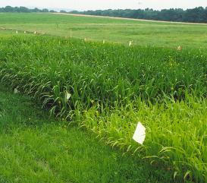  Fields with adequate (left) and inadequate (right) nitrogen.  (original image location)

Phosphorus
Phosphorus is another essential macronutrient whose deficiency is a major consideration in cropping systems. It is an essential part of the components of DNA and RNA, and is involved in cell membrane function and integrity. It is also a component of the ATP system, the "energy currency" of plants and animals. Phosphorus deficiency is seen as purple or reddish discolorations of plant leaves, and is accompanied by poor growth of the plant and roots, reduced yield and early fruit drop, and delayed maturity. Phosphorus excess can also present problems, though it is not as common. Excess P can induce a zinc deficiency through biochemical interactions. Phosphorus is generally immobile in the soil, which influences its application methods, and is somewhat mobile in plants. | 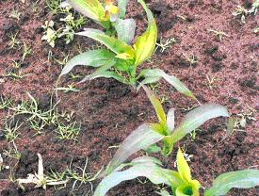  Growing plants show the purple leaves characteristic of phosphorus deficiency.  (image source)

Potassium
Potassium is the third most commonly supplemented macronutrient. It has important functions in plant metabolism, is part of the regulation of water loss, and is necessary for adaptations to stress (such as drought and cold). Plants that are deficient in potassium may exhibit reductions in yield before any visible symptoms are noticed. These symptoms include yellowing of the margins and veins and crinkling or rolling of the leaves. An excess, meanwhile, will result in reduced plant uptake of magnesium, due to chemical interactions. | 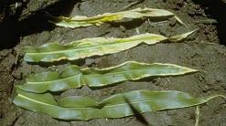  Potassium deficiency (photo courtesy of Department of Soil Science, University of Wisconsin (image source))

PO 4. Distinguish each macronutrient as mobile or immobile in the plant.
- The mobility of a nutrient in the soil determines how much can be lost due to leaching or runoff.
- The mobility of a nutrient in the plant determines where deficiency symptoms show up.
  - Nutrients that are mobile in the plant will move to new growth areas, so the deficiency symptoms will first show up in older leaves.
  - Nutrients that are not mobile in the plant will not move to new growth areas, so deficiency symptoms will first show up in the new growth.
Nutrient mobility varies among the essential elements, and represents an important consideration when planning fertilizer applications. For instance, NO₃⁻ nitrogen is very mobile in the soil, and will leach easily. Excessive or improper application increases the risk of water contamination. Meanwhile, phosphorus is relatively immobile in the soil, and is thus less likely to runoff. At the same time, it is also less available to plants, as it cannot "migrate" easily through the soil profile. Thus, P is often banded close to seeds to make sure it can be reached by starting roots.
Nutrients also have variable degrees of mobility in the plant, which influences where deficiency symptoms appear. For nutrients like nitrogen, phosphorus, and potassium, which are mobile in the plant, deficiency symptoms will appear in older leaves. As new leaves develop, they will take the nutrients from the old leaves and use them to grow. The old leaves are then left without enough nutrients, and display the symptoms. The opposite is true of immobile nutrients like calcium; the new leaves will have symptoms first because they cannot take nutrients from the old leaves, and there is not enough in the soil for their needs.

Guide to Nutrient Deficiencies
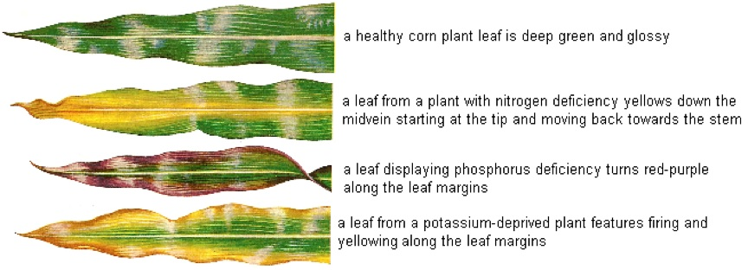

PO 5. List chemical uptake forms for each macronutrient.
- Nitrogen: nitrate (NO₃⁻) and ammonium (NH₄⁺)
- Phosphorus: phosphate (HPO₄²⁻ and H₂PO₄⁻)
- Potassium: K⁺
- Calcium: Ca²⁺
- Magnesium: Mg²⁺
- Sulfur: sulfate (SO₄⁻)

PO 6. Describe how nutrient demands change at different plant growth stages.
In general, plant nutrient needs start low while the plants are young and small, increases rapidly through vegetative growth, and then decreases again around the time of reproductive development (i.e., silking and tasseling). While absolute nutrient requirements may be low for young plants, they often require or benefit from high levels in the soil around them. The nutrient status of the early seedling will affect the overall plant development and yield. Plants entering the reproductive stages have high nutrient requirements, but many of these are satisfied by redistributing nutrients from the vegetative parts.

Click below to learn about how nutrient demands change over time.

Summary
- Plants require 18 essential nutrients to grow and survive, classified by their importance into macronutrients (C, H, O, N, P, K, Ca, Mg, S) and micronutrients (B, Cu, Fe, Mn, Zn, Mo, Cl, Co, Ni). Study Tip!
- Nutrients may be mobile or immobile in the plant and in the soil, which influences redistribution of nutrients and display of deficiency symptoms, and the fertilization of crops.
- Nutrient demands change throughout the life of the plant, in general increasing during vegetative growth but decreasing during reproductive development.

