EFFECTS OF DIFFUSED LIGHT ON LARGE CONTAINER POINSETTIAS
A. Murphy, R. Ward, Plant Science Division 5
Parkside High CTE Horticulture FFA Wicomico, Maryland

This study aimed to analyze the comparative growth response of large multi- cutting potted
poinsettias to direct and diffused light. The hypothesis was that crop photosynthesis is enhanced in diffused light with direct effects of more uniform vertical and horizontal light distribution. Numerous studies from other crop research have concluded that diffused light penetrates deeper into the crop canopy. This study is of particular interest as the bract/leaf morphological structure of Euphorbia pulcherrima becomes increasingly large as they approach finish and can limit underlying leaf light use efficiency.

The study used height and branching measurements throughout the six-week study to determine
growth rates of Euphorbia pulcherrima var. ‘Mars’. Additionally, a leaf area index (LAI) was conducted in the first and last week of study to determine leaf development of both the direct and diffused light study groups. Chlorophyll testing of leaves was conducted to compare photosynthetic rate of top third and bottom third of plants during the course of study.

The container poinsettias in the greenhouse with the light diffusion screens resulted in increases in height and branching and 40% higher total area bract/leaf development during the six weeks of study. These increases were reflected from the higher average chlorophyll measurements in both the lower and upper leaves during the course of the six weeks study.
Introduction

Poinsettia growers face multiple challenges in the quest to produce vigorous and healthy plants. Alongside proper nutritional and temperature considerations, lighting is a major consideration in the bract/leaf development and overall vigor of plants. Poinsettias require medium to bright lighting during the growth stage of the plant before finish. As poinsettias are grown for market in the fall season, fluctuating light and spans of intensity can disrupt desired form. Generally, longer high light intensities can diminish height and proportionally enlarge upper bracts, while longer lower light intensities can stretch plant height and diminish bract formation. The consideration for this study was to research the effectiveness of light diffusing screens, thereby maximizing light availability to plants from the expected fluctuating light transmittance during fall growing period.
Plants use diffuse light more efficiently than direct light, which is well established
due to diffuse light penetrates deeper into the canopy and photosynthetic rate of a single
leaf shows a non-linear response to the light flux density. Diffuse light also results in a
more even horizontal and temporal light distribution in the canopy. High light level usually leads to photosynthetic saturation and decrease in light use efficiency. (Tao,
2015, p1)
As indicated, diffuse light scatters in many directions and thus causes less shadow, while direct light either concentrates in a beam, or casts a shadow on the canopy leaving lower leaves in deep shade, or strong sunflecks at a particular canopy depth. (See Figure 1.)
This study focused on larger container multi-cutting poinsettias as these larger plantings can readily exhibit detriments when lighting factors are not aligned. This study focused on the period from prefinished transplant root establishment in larger pot (Wk.43 10/24) to finish (Wk. 48 11/30) In the one study group plants were grown in a twin walled polycarbonate covered greenhouse and in the other study group the plants were grown in a polycarbonate greenhouse with light diffusing screens encompassing two sides of structure. All plant nutrition, moisture and temperature considerations were duplicated for both study groups.
Literature Review
A study from Belgium investigated the use of light diffused glass in the greenhouse production of tomatoes and peppers. Significant production increases of 7.5% were accomplished during the course of the study. The study pointed out that the benefit of the diffused glass was most relevant during sunny clear skies and on the sun-side-facing rows of crops. An interesting finding from this study was that plants exposed to high light levels adapt with thicker mesophyll leaf layers cancelling potential photosynthetic gains of future diffused light exposure.
In these fully exposed thick leaves, diffuse light has a lower penetration depth, which reduces the net photosynthetic capacity compared to direct light. Shaded leaves, however, do not discriminate between light directions and thus maintain the same photosynthetic capacity for both direct and indirect light. (Kristof, 2020, p. 2)
(Maria, 2021) studied the comparative growth response of tomatoes using two different levels of light transmission with similar diffusion factors. The marketable yield of tomatoes was comparatively 3.2% higher with a 5% higher light transmittance screen and similar light diffusion parameters of 55%. The production improvements were due to both the increase in average weight of fruits and number of fruits per plant. This study highlights that certain crops are advantaged with both higher light transmittance alongside high light diffusion capacities.
A study in Japan used light diffusion screens to mitigate shading caused by the use of solar panels on the roof of their greenhouses. The solar panel shading had negatively affected the production of both lettuce and onion crops. Light diffusion screens installed underneath the solar panels in the greenhouse provided a more uniform light distribution compared to control for the lettuce production investigated.
Diffused light improved lettuce growth. The leaves became wider and the ratio of leaf width to length was close to that in the control in spring, summer, and fall cultivations. Although the net photosynthetic rate of fully expanded leaves of lettuce grown under diffused light was lowest, the dry weight and relative growth rate was comparable to the control in summer and fall cultivations. (Alkira, 2014, p.148)
Materials and Methods.
The plants used in this study were 18 prefinished poinsettias - Euphorbia pulcherrima var. ‘Mars’ Plants were received in 41/2-inch pots and transplanted immediately into 10” pots with three in each pot. Plants were received in Week 39, Sept 27 and put in the greenhouse with heated benches to promote rooting. Fungicides and starter fertilizers were applied to all plants alongside appropriate temperature and moisture monitoring until plants were established in containers.
In week 43 October 27, poinsettias were distributed to study location with 3 containers placed in the greenhouse (Diffuse House) with light diffusion screens and 3 containers placed in the twin-walled polycarbonate greenhouse (Poly House). Plants in each greenhouse were appropriately spaced for equal light accessibility.
During the course of study all plants were monitored and treated equally in fertilizer and moisture applications. Additionally, ambient and soil temperatures were monitored daily so that plants in both study groups received the same day and night temperatures. Both study groups were PH and EC tested weekly to assure both groups were aligned together with appropriate cultural nutrient status.
Both greenhouses (Diffuse House), (Poly House) have double walled polycarbonate roofs which capture approximately 75% of direct light. The Diffuse House has light diffusion screens on east and west sides of the greenhouse that shade up to 30% of the direct light. Additionally, these light diffusion screens scatter 53% of light entering from both ends of the greenhouse. The Poly House has no light scattering elements outside or within the greenhouse. (See Figure 1.) Photosynthetic Active Radiation (PAR) umdm2s readings were taken each week to measure the light incidence readings at plant level. (See Table 1.) Poly House had on average 19% greater PAR direct lighting incidence than the Diffuse House.
Figure 1. Poly House Diffuse House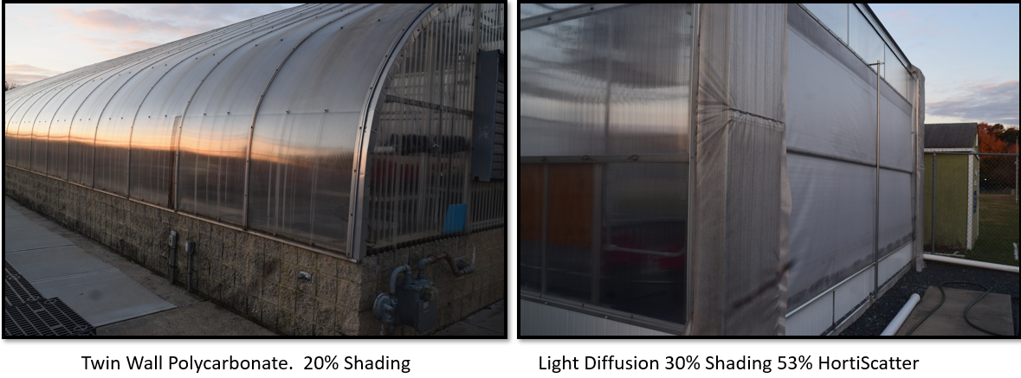
Measurements
In the beginning week of study (Week 43) a leaf area index was undertaken of one plant from each study group. The leaf area index entails destructively taking all leaves from plants and measuring the total area in square centimeters of all leaves and dividing the total by the area encompassed by the plant canopy. These measurements were duplicated at the end of study (Week 49) to compare the total bract/leaf growth parameters of each study group.
Each week measurements were documented of plant height and branching. Additionally, each week chlorophyll readings of leaves were undertaken for each study group. Readings were documented from both the upper and lower 1/3 of the plant. Chlorophyll readings were undertaken using an atLEAF chlorophyll meter. (See Table 2) As mentioned, each week sample light readings were undertaken at plant level to measure for comparative analysis, the light capture of each greenhouse.
Results
As hypothesized, the poinsettias grown in the Diffuse House over six weeks produced significant gains comparatively in height 21% (Table 1.), branching 14%, and in leaf area 39%. (Table 3.) Of note, was the respective higher chlorophyll measurements of plants in the Diffuse House. On average chlorophyll readings from the Diffuse House were 11% higher on upper leaves and 16% higher on lower leaves compared to Poly House.(Table 2.)
Table 1. Poinsettia: Height/ Branching/ Lighting
Week | Height”  Poly  House | Height”  Diffuse  House | Branching”  Poly  House | Branching”  Diffuse  House | Par*  Light  Poly House | Par*  Light  Diffuse  House
43 | 6.0 | 6.0 | 12 | 12 | 483 | 341
44 | 7.0 | 7.5 | 12 | 12 | 408 | 300
45 | 7.0 | 8.0 | 13 | 13 | 513 | 460
46 | 9.0 | 10.0 | 14 | 16 | 336 | 255
47 | 9.0 | 11.0 | 14 | 16 | 725 | 637
48 | 9.5 | 11.5 | 14 | 16 | 680 | 650
Avg. |  |  |  |  | 524 | 440
+/-% |  | +21% |  | +14% | +19 %
* Photosynthetic Active Radiation umdm2s
Table 2. Poinsettia Bract: Chlorophyll Measurements (atLEAF)
Week | Chlorophyll  Upper Leaves Poly  House | Chlorophyll  Upper Leaves Diffuse  House | Chlorophyll  Lower Leaves Poly  House | Chlorophyll  Lower Leaves  Diffuse  House
43 | 54 | 58 | 58 | 70
44 | 57 | 59 | 56 | 66
45 | 51 | 58 | 46 | 65
46 | 59 | 65 | 61 | 64
47 | 56 | 62 | 52 | 63
48 | 55 | 66 | 49 | 58
Avg. | 55 | 61 | 57 | 64
+/-% |  | +11% |  | +16%

Table 3. Leaf Area Index
 | Leaf Area cm | Area Canopy cm | LAI | +/- %
Week 43 Poly | 1504 | 1100 | 1.36
Week 49 Poly | 3960 | 1800 | 2.20 | +62%
 | Leaf Area cm | Area Canopy cm | LAI
Week 43 Diffused | 1698 | 1100 | 1.54
Week 49 Diffused | 5591 | 1800 | 3.10 | +101%

Conclusions
Production values and the finished quality of poinsettias is gained by the use of light diffusion screens. This study collaborated with other crop research in the use of light diffusion techniques to increase the available light and efficiency reaching the cultivated crop. In this study 5% gains in average lower leaf chlorophyll readings alongside average chlorophyll gains of 11% of upper leaves ultimately produced a more vigorous and dense plant. (See Figure 3) The light diffused by screens reduces the amount of leaf shading particularly from upper leaves in the canopy. (See Figure 2) This increase in light on both the horizontal and vertical access produces gains in photosynthetic production throughout the growth to finish stages of production.
As only one red variety of poinsettia was studied, future studies should include other poinsettia cultivars and particularly other color varieties. This study could also be applied to other important ornamental greenhouse crops.
Figure 2: Week 46 Poly House Diffuse House
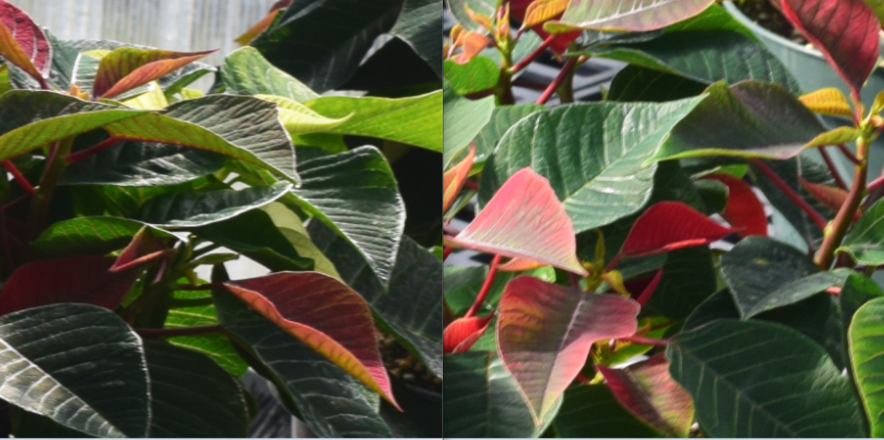

Figure 3: Week 49 Poly House Diffuse House
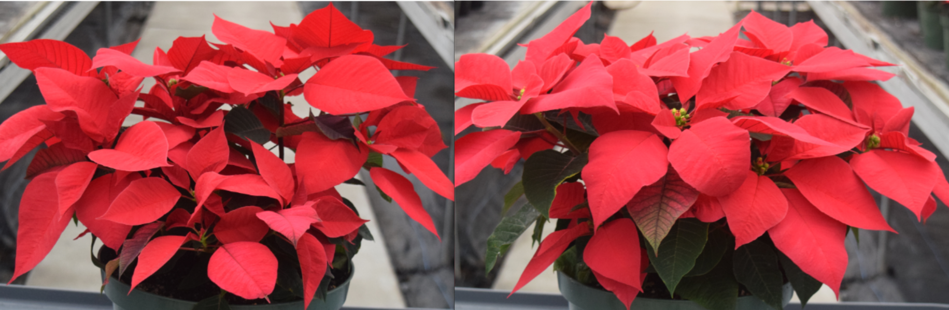

References

Akira TANI, Kazuki NAKASHIMA, Makio HAYASHI, & Suguru SHIINA. (2014).
Improvement in lettuce growth by light diffusion under solar panels. Journal of
Agricultural Meteorology, 70(3), 139. https://doi-org.proxy-
es.researchport.umd.edu/10.2480/agrmet.D-14-00005

Kristof Holsteens, Rob Moerkens, Bram Van de Poel, & Wendy Vanlommel. (2020). The Effect
of Low-Haze Diffuse Glass on Greenhouse Tomato and Bell Pepper Production and
Light Distribution Properties. Plants, 9(806), 806. https://doi.org/10.3390/plants9070806

María de los Ángeles Moreno-Teruel, Francisco Domingo Molina-Aiz, Araceli Peña-Fernández,
Alejandro López-Martínez, & Diego Luis Valera-Martínez. (2021). The Effect of Diffuse
Film Covers on Microclimate and Growth and Production of Tomato (Solanum
lycopersicum L.) in a Mediterranean Greenhouse. Agronomy, 11(860), 860. https://doi-o
rg.proxy-es.researchport.umd.edu/10.3390/agronomy11050860

Tao eLi, & Qichang eYang. (2015). Advantages of Diffuse Light for Horticultural Production
and Perspectives for Further Research. Frontiers in Plant Science, 6. https://doi-
org.proxy-es.researchport.umd.edu/10.3389/fpls.2015.00704

