Transplant and Drought Response of Chrysanthemum (Morifolium) to Vegetable Based Protein Hydrolysate Applications.

Lily Pedersen and Phoebe Klaverweiden, Plant Science Division 4
Parkside High CTE Horticulture, FFA Wicomico, Maryland

Growers are continually reaching for optimum plant development within the environment of soil or soilless growing environments. Additionally, growers are facing abundant challenges related to plant stresses associated with climate impacts. Plant derived protein-based hydrolysates have shown potential to increase the germination, productivity, and quality of a wide range of horticultural and agriculture crops. Plant hydrolysates have also shown promise in mitigating the negative effects of plant stress including drought, and heavy metals.

An important consideration in using protein hydrolysates is the mode of application and the corresponding efficiency related to plant health. This ten-week study trialed the effectiveness of using water soluble plant protein hydrolysates as both a foliar and substrate drench on container chrysanthemums. The study hypothesized that the hydrolysate applications would have a significant positive impact on mum growth and drought tolerance.

The two-week intervals of substrate and foliar applications of liquid protein hydrolysates showed significant gains in chrysanthemum growth, transplant and drought tolerance compared to control.

Introduction

Chrysanthemum container growers face multiple challenges in the quest to produce vigorous plants. From transplant to finish container chrysanthemums are grown during the summer for fall retail. Generally, container grown crops present challenges as the plants available moisture and nutrients reside only in the pot. Specifically, container grown chrysanthemums are heavy feeders regarding nutrients and due to their large leaf mass are susceptible to water loss through transpiration. Wilting during the production months of summer can restrict root formation and branching. On days of excessive temperatures and through periods of drought growers often will rely on daily and sometimes multiple daily irrigation events to maintain their crop. These multiples of irrigation events can be problematic as available nutrients can be washed out through the pot and need to be replaced. Impacts of increasing temperature stress on plants make it critically important for growers to manage that plants don’t reach wilting or permanent wilting point.

Multiple studies from the vegetable and succulent growing industry sectors has shown that the application of plant derived protein hydrolysates (PHs) have been extremely beneficial in improving root development, nutrient uptake, as well as improving drought tolerance. The transfer of the information regarding hydrolysate application rates and timing from the vegetable and succulent studies would be difficult to mimic as mums have different needs. This study used the product (Biomin N) and suggested application rates for general agriculture crops: Every two-week application at 1gallon to 100-gallon injection ratio. This study investigated the application method of drenching the pot substrate versus foliar application in comparison to the control with no applications. The study also compared the relative drought tolerance of the study groups at the completion of the eight-week growth period. It is hypothesized that the application of the (PHs) would show measurable gains in chrysanthemum growth and drought tolerance.

Literature Review

A study investigating the use of protein hydrolysates on succulents reported significant gains on all important test measurements. The study reported significant increase in leaf counts, vegetative and root weight, and number of flowers. “The application of hydrolyzed proteins in plant cultivation and in succulents, allows higher quality standards of the product, higher resistance to biotic and abiotic stress, increased growth rate. (Prisa, p.1.)
(Baglieri, et.al, 2014), reported similar results using plant derived hydrolysates on field grown beans, tomatoes, and peppers.
These substances were isolated and applied separately to a loamy–sandy soil for tomato and red pepper (in greenhouse cultivation.) The soluble substances were found to enhance leaf chlorophyll content, and to improve plant growth and fruit ripening rate and yield over the crop production cycle, significantly more than the sourcing compost and the co-produced insoluble residue. The increases amounted to 90% for the precocious crop yield, to 66% for the total crop production, and to 17% for the per fruit weight. (p.1)
Numerous mechanisms regulate the benefits for improved plant health with the application of these protein hydrolysates. Recent studies are uncovering that PHs could be stimulating carbon and nitrogen metabolism and interfering with hormonal activity.
Indirect effects could also play a role as PHs could enhance nutrient availability in plant growth substrates and increase nutrient uptake and nutrient-use efficiency in plants. Moreover, the beneficial effects of PHs also could be due to the stimulation of plant microbiomes. Plants are colonized by an abundant and diverse assortment of microbial taxa that can help plants acquire nutrients and water and withstand biotic and abiotic stress. The biostimulant activity observed in response to the application of PHs could be acting, at least in part, indirectly through a microbially mediated enhancement of plant health. (Colla et al., 2014, p.3)
A tomato plant study found significant improvement in root growth associated with using PHs as root drench. “The application of legume-derived PH especially as a substrate drench enhanced method. The increase in plant biomass was associated to the stimulation of the root growth, thus inducing a “nutrient acquisition response” that favors N uptake and translocation.” (Francesco Sestili, p.12)
Materials and Methods
The plants used in this study were thirty chrysanthemums (Chelsey Yellow Plugs) and were planted in 8” mum pans on raised benches using drip lines.
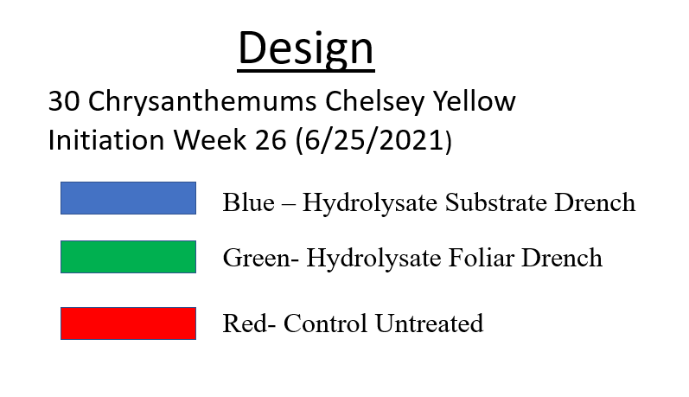
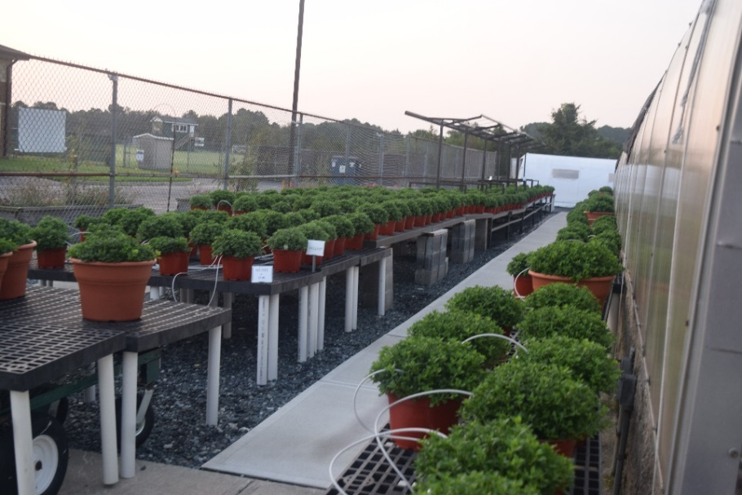
Procedures
Each study group (Blue – Hydrolysate Substrate Drench), (Green- Hydrolysate Foliar Drench), (Red- Control) were randomized across outside growing benches.
Study began in week 26 (June 25) and completed week 36. (August 28)
All plants receive 20/10/20 or 15/0/15 fertilizer weekly. For all plants the target EC is 1.5 during rooting, 2.0 during growth, and 1.0 toward finishing in week 34. Protein Hydrolysate drench is applied every two weeks starting in week 26 through week 34 for the two study groups.
Measurement
For each plant group, recorded height and number of branches is taken every two weeks: Week 26, 28, 30, 32, 34. One plant from each group is taken in week 30 and 34 and measured dry weight is recorded.
In week 35 (3) plants from each study group were separated out and fully saturated. Observations recorded for the following 3 days as plants received no moisture.
Fertlizer
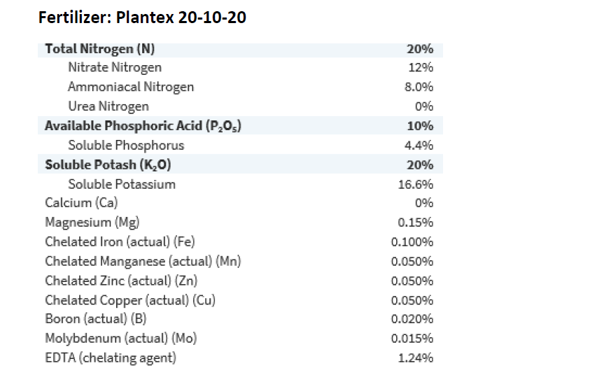
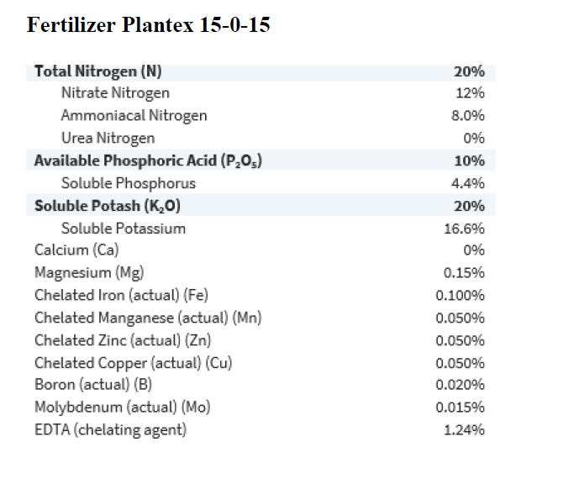
Protein Hydrolysate -Biomin N
Label
Biomin N, 5-0-0 is an OMRI Certified liquid fertilizer with 5% nitrogen that's made to supply crucial nitrogen to plants. Nitrogen is key to overall plant health; it is a fundamental component of enzymes, proteins and photosynthesis as well as being essential to plant and leaf growth and seed and fruit production. This organic fertilizer is not made with any animal products or by-products; it is derived from non-GMO hydrolyzed soy proteins that are sourced in an environmentally friendly manner. These vegetable proteins help create a fertilizer that is water soluble (to readily supply the nitrogen to the plants) with a high amino nitrogen content and a lower salt index.
Results
As hypothesized the application of the protein hydrolysate had significant contribution to height, branching, and biomass compared to the control. (See Figure 1,2,3) We found in the first four weeks in establishment of plugs a significant gain of an inch in height of the substrate group compared to control. The foliar gains were half as significant compared to the substrate gains. In last four weeks of study there were again comparative gains in height of the substrate and foliar groups compared to control. As would be expected the branching measurements reflected similar gains in the application groups compared to control. In total biomass the gains of both the foliar and substrate groups compared to control were significant. After the first four weeks of study the biomass of the application groups increased 20% over control. In following four weeks those gains continued with biomass gains of substrate group at 30% and biomass gains of foliar group 24% over control. Figure 4 reflects substantial gains in root formation of substrate group sample compared to foliar and control group samples.

Figure 5 Week 35 observations of drought tolerance during three-day period of high temperatures reflected wilting initiation began with control group plant in first 24 hours, Wilting began in foliar group plant in second 24 hours. The substrate representative sample showed slight wilting in second 24 hours on two branches.
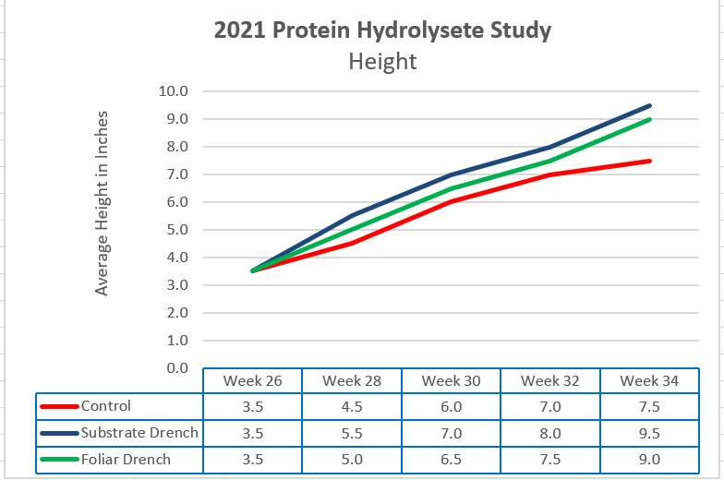
Figure 1. Height
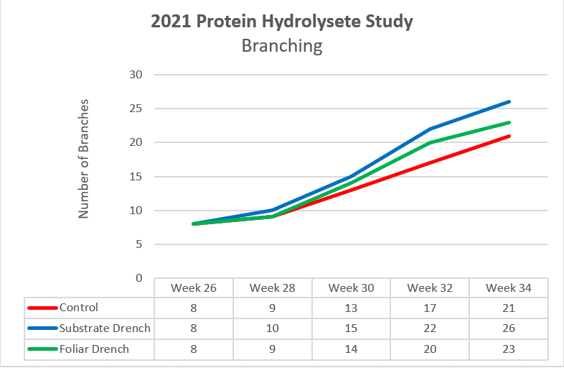
Figure 2. Branching
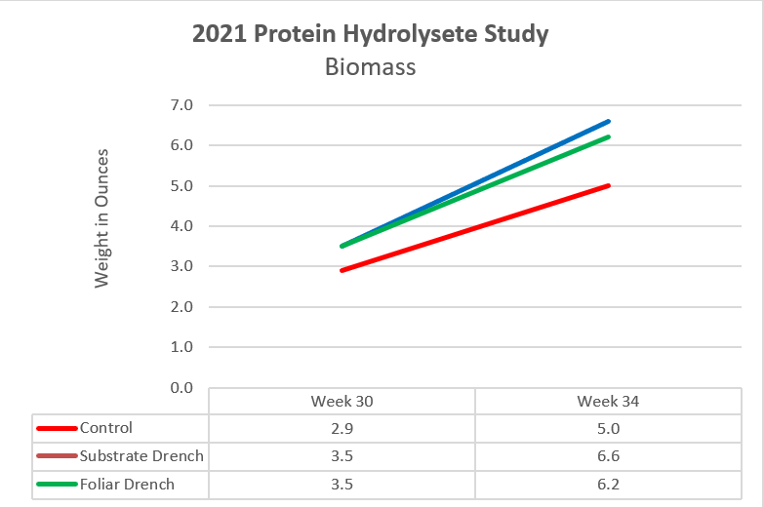
Figure 3 Biomass
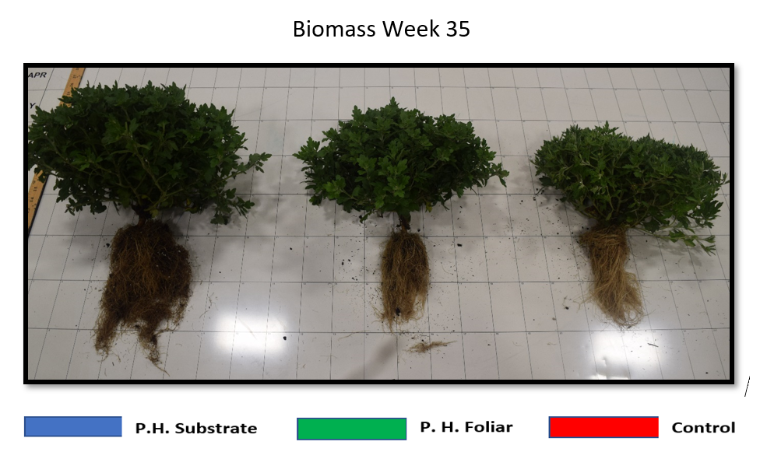
Figure 4. Biomass Comparison

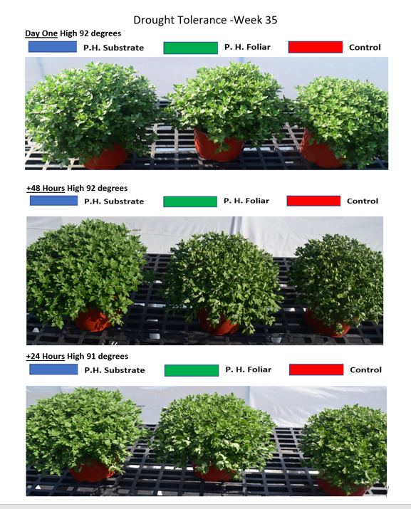
Figure 5. Drought Tolerance

Summary and Conclusions
Nursery and greenhouse growers want to grow beautiful and vigorous plants that not only sell but do well once planted. Growers are looking for (1) improved plant root development and growth (2) increased quality and quantity of flowers/fruits (3) improved nutrient and water intake (4) increased resistance to stress, root disease and transplant shock. This initial study showed that the use of protein hydrolysates as an amendment to the substrate or as a foliar application can have positive benefits respective to the above goals.
The significant increases in plant establishment and growth in first four weeks using the PHs reduced the transplant stress and improved the initial establishment of plants compared to control. These initial benefits reflected stronger root establishment and supported continued improved growth and tolerance of increasing temperature stress in summer growing period. The study suggests that the substrate drench was more beneficial in root establishment and vigorous growth in comparison to foliar applications. The ability of the substrate group to comparatively withstand drought tolerance was significant. The substrate group with the larger mass of shoot development should have transpired moisture at more rapid rates then other groups. This relative improvement in drought tolerance would pay dividends in maintaining crop for growers and improve performance for customers.
As only one crop was studied future studies should include other ornamental crops should be evaluated using protein hydrolysates during production.
Acknowledgements
We would like to thank our advisor Mr. Jerry Kelley for supporting this research with ideas
related to production protocols and measurement formats. We would like to thank our fellow
chapter members who provided support with maintaining crop i.e., watering and spacing.

References
Baglieri, A., Cadili, V., Mozzetti Monterumici, C., Gennari, M., Tabasso, S., Montoneri, E., Nardi, S., & Negre, M. (2014). Fertilization of bean plants with tomato plants hydrolysates. Effect on biomass production, chlorophyll content and N assimilation. Scientia Horticulturae, 176, 194–199. https://doi-org.proxy- es.researchport.umd.edu/10.1016/j.scienta.2014.07.002
Colla, G., Rouphael, Y., Canaguier, R., Svecova, E., and Cardarelli, M. (2014). Biostimulant action of a plant-derived protein hydrolysate produced through enzymatic hydrolysis. Front. Plant Sci. 5:448. doi: 10.3389/fpls.2014.00448
Francesco Sestili, Youssef Rouphael, Mariateresa Cardarelli, Anna Pucci, Paolo Bonini, Renaud Canaguier, & Giuseppe Colla. (2018). Protein Hydrolysate Stimulates Growth in Tomato Coupled with N-Dependent Gene Expression Involved in N Assimilation. Frontiers in Plant Science, 9. https://doi.org/10.3389/fpls.2018.01233
Prisa D. (2020). Effect of vegetable protein hydrolysates on the growth of Adromischus cooperi and Adromischus cristatus. World Journal of Advanced Research and Reviews, 6(3), 01- 06.

