Youth Environmental Action Summit
Parkside High Pocket Meadow
Budget
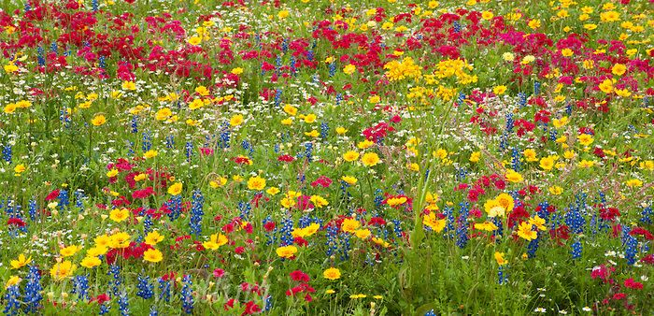

Item Total Donated Yeas Request
1. Seed 3Lbs American Meadow Seed $98.85
2. Weed barrier 1 Roll $189.00
Total Needed $287.95

